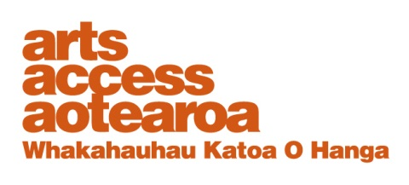
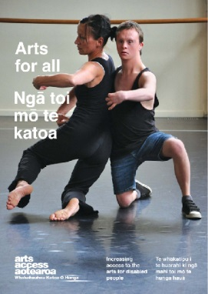
Access symbols: information sheet

There is a range of internationally recognised symbols that publicise and promote accessibility. This information sheet describes the various symbols, where you can download them and where to use them.

You can download images of the 12 symbols from the Graphic Artists Guild website (graphicartistsguild.org or http://bit.ly/1ylvD85) or contact Arts Access Aotearoa.

Using the access symbols

Access symbols can be used in advertisements, newsletters, websites, emails, conference and programme brochures, membership forms, building signage, floor plans and maps.

The best-known symbol is the International Symbol of Access (ISA), which is used to identify or show the way to buildings and facilities that are accessible to people with impaired mobility.

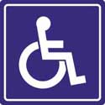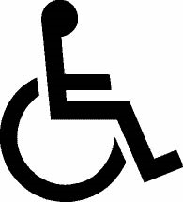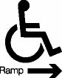

Using symbols, as well as accompanying text captions, makes the information available to all your audience members. For example, the international symbol for access, accompanied by the text “ramped access”, includes parents with buggies, senior citizens and people with impaired mobility.
Arts For All is an Arts Access
Aotearoa/Creative
New Zealand partnership programme. The aim of this programme is to encourage arts
organisations, venues and producers to improve their
access to disabled audiences.
Download the guide Arts For All, published in 2014 by Arts Access Aotearoa, at artsaccess.org.nz
or call 04 802 4349
for a hard copy.

Barrier Free New Zealand Trust (www.barrierfreenz.org.nz) manages the display of the ISA and provides information on building access. Barrier Free can also assist in the display and requirements of access symbols.

The 12 access symbols
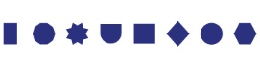
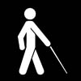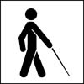
This symbol indicates access for people who are blind or have low vision, best used in places such as a guided tour, a path in a park or a tactile tour or a museum exhibition that may be touched.
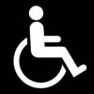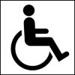
This symbol indicates access for individuals with limited mobility, including wheelchair users. A ramped entrance is not completely accessible if there are no curb cuts, and an elevator is not accessible if it can only be reached via steps.

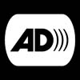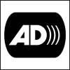
This symbol indicates that the event or activity is audio described for people blind or have low vision.
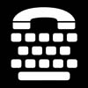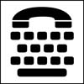
This telephone typewriter (TTY) indicates there is a device used with the telephone for communication with and between Deaf, hard of hearing, speech impaired and/or hearing people.
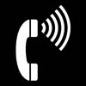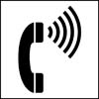
This symbol indicates telephones that have handsets with amplified sound and/or adjustable volume controls.
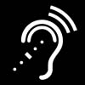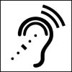
This symbol indicates assistive listening systems, which transmit amplified sound via hearing aids, headsets or other devices.
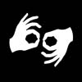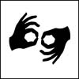
This symbol indicates that Sign Language Interpretation is provided for a lecture, tour, film, performance, conference or other programme.

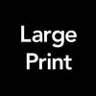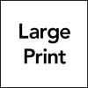
Large print is indicated by the words “Large Print,” printed in sans serif font and in 16pt or larger text.
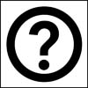
This information symbol indicates the location for specific information or materials concerning access: e.g. large print materials, audio recordings of materials, or sign interpreted tours.
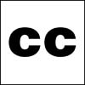
This symbol indicates closed captioning, commonly known as subtitles. It enables people who are Deaf or hard of hearing to read a transcript of the audio portion of a video, film, exhibition or other presentation.

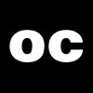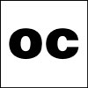
This symbol indicates open captioning. It differs from closed captioning because it does not offer a choice of turning it off or on. It also includes descriptions of sound.
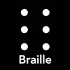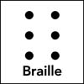
This symbol indicates that printed material is available in braille, including exhibition labelling, publications and signage.

Contact Arts Access Aotearoa:
T: 04 802 4349
E: info@artsaccess.org.nz
W: www.artsaccess.org.nz

