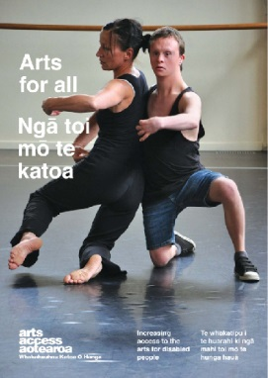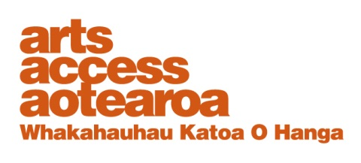**Ticketing and seating: a checklist**

Ticketing and seating procedures affect an audience member’s experience of arts events: for example, the flexibility of a seating policy; the response people get when they phone to enquire about accessible seats; and the systems for booking accessible seats.

Arts For All is an Arts Access

Aotearoa/Creative   
New Zealand partnership programme. It aims

to encourage arts

organisations, venues and producers to improve their

access to disabled audiences.

Download the guide *Arts For All,* published in 2014 by Arts Access Aotearoa, at [artsaccess.org.nz](http://artsaccess.org.nz/arts-for-all/introducing-arts-for-all)

or call 04 802 4349 for a hard copy.

**Pricing policies**

There are arguments for and against offering discounted tickets. *Arts For All* (page 33) lists some arguments for and against discounted tickets. Considering these different perspectives will help you develop a ticketing policy. For example:

* Disabled people often have low incomes and high living costs.
* Disabled people often need to bring a companion to an arts event and pay for that person’s ticket as well as their own ticket.
* Disabled people sometimes have to buy a more expensive ticket: e.g. a Deaf person may need a seat in a premium front row to see the New Zealand Sign Language interpreter.
* Offering discounted tickets for disabled people means they are not being treated equally. If disabled people are unwaged or senior citizens, they can claim these discounts. If they are employed, they should pay the same price as anyone else.
* It may cause issues deciding who qualifies for a discount: e.g. students must show a current student ID but how do you request proof of disability, especially if someone has a hidden impairment?

Arts organisations need to cover costs and the idea of reducing the price of tickets or providing a free ticket for companions may have little appeal. But

think about ticket pricing and discounts as a marketing tool – a way to reduce barriers, attract disabled people, and build a loyal audience not only of disabled people but also of their family, whānau and friends.

**Booking tickets**

Ticketing offices can be difficult places to access: e.g. the counters are often too high for wheelchair users to see over. What other options do people have to book tickets? If it’s online, is it easy and accessible?

If you use a ticketing agency, find out its processes for ensuring all people have access to your events.

If you choose to offer discounted tickets:

* develop a clear ticketing policy that outlines procedure and practice, and reflects the venue’s seating policy
* ensure all staff, especially those handling bookings and enquiries, are familiar with this policy
* communicate clearly who is responsible in specific situations: e.g. if you receive a complaint about discriminatory practice or unsuitable seating.

**Seating policies**

Providing spaces for people who use wheelchairs is not the only access consideration for venues.

|  |  |  |  |
| --- | --- | --- | --- |
| **Seating** | **Yes** | **No** | **Comments** |
| Do you provide wheelchair spaces?  Do you have two wheelchair spaces for up to 250 seats, and one for each additional 250 seats? |  |  |  |
| Are wheelchair spaces integrated into seating areas, with a choice of viewing positions, and with adjacent companion seating? |  |  |  |
| If you venue is sloped, are there level areas where people using wheelchairs can be seated? |  |  |  |
| If your venue has a lot of steps, do you set aside aisle seats on the first row of each level? |  |  |  |
| Can service dogs come into your venue and remain alongside, or under the chair of their owners? The law allows for this. |  |  |  |
| Do you have aisle seats with removable arm rests for people who wish to transfer from wheelchairs? |  |  |  |
| Do you have procedures in place for storing wheelchairs and other equipment, as well as returning them at intervals, emergencies and the end of the event? |  |  |  |
| If you have hearing loops or infra-red systems, do you set aside seats that enable the best use of these systems? Do your staff know how to operate them? |  |  |  |
| If a New Zealand Sign Language interpreter is at an event, do you set aside seats so that Deaf audience members can best see the interpreter and the event? |  |  |  |
| Are there tread lights or flare paths to indicate pathways when lights are dimmed? |  |  |  |
| Are row and seat numbers large, clear and suitably lit? |  |  |  |
| Are lighting levels adequate when the audience arrives, leaves and in case of emergency? |  |  |  |

**Contact Arts Access Aotearoa:**

T: 04 802 4349

E: [info@artsaccess.org.nz](mailto:info@artsaccess.org.nz)

W: www.artsaccess.org.nz

**Disclaimer:**

The material in this checklist is intended as a general guide only and should not be relied on as a substitute for technical, legal or other professional advice. While care has been taken in the preparation of this material, the writers and publishers do not accept responsibility for any errors or omissions, or for the result of any actions taken on the basis of this information.