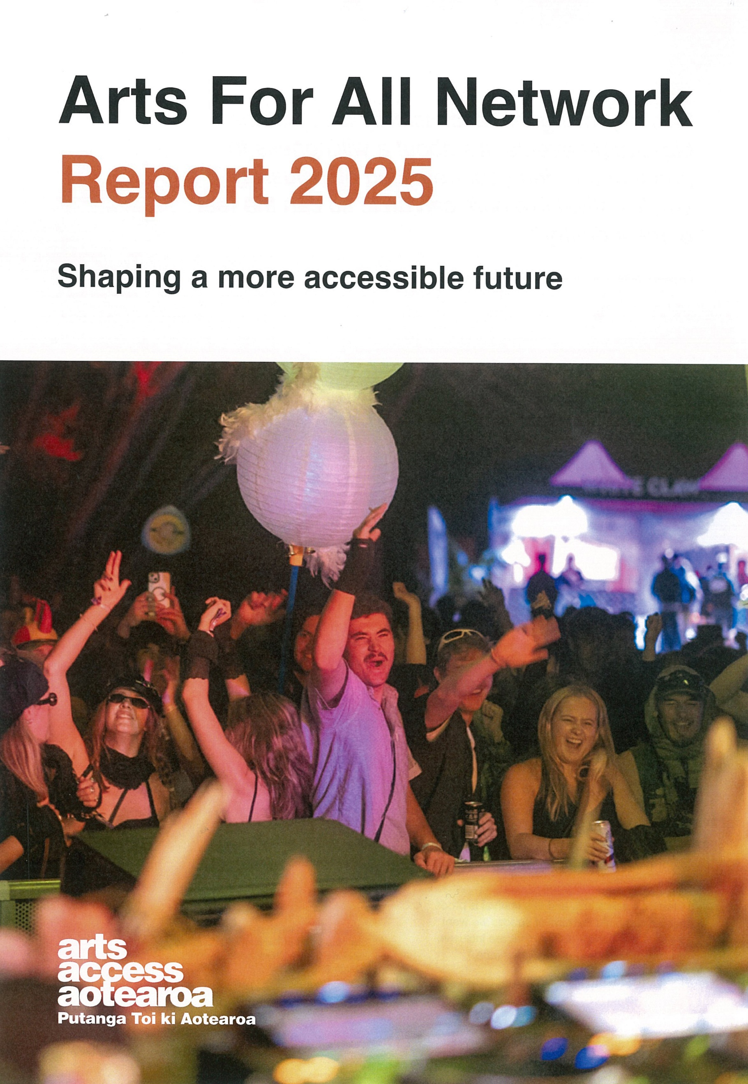

Cover image: Festival-goers enjoy the closing set of Twominds Festival, held in Ōtautahi Christchurch in March 2025 Photo: Lucas Perelini

Arts For All Network Report 2025

Overview
In February 2025, the annual Arts For All Network survey was sent out to all Network members, asking them questions about their accessibility work and progress in 2024. This annual survey provides a way for Network members to give feedback, make requests and share thoughts, and for us to see how the sector is progressing towards increased accessibility. Your answers shape how we work and plan to best serve you. Here’s the report of our findings and how we plan to put your feedback into action.

What the members tell us
Respondents reflected on their accessibility work as a mix of positivity and challenge. Many described their connection with this work as enriching, transformative and deeply rewarding, with a growing understanding of accessibility and the benefits it brings to both artists and communities. Creative breakthroughs, increased inclusion, seeing tangible results, and stronger relationships with Deaf and disabled artists were important outcomes.
At the same time, there are ongoing barriers. Engagement with accessibility is often described as a long, winding journey. Some reported strong intentions that had been delayed or disrupted by staff turnover, competing or shifting priorities, or resource limitations. Members say they need continued support to maintain momentum. These findings show the value of past efforts and the need for ongoing, practical support to deepen and sustain accessibility. Despite challenges, there are signs of meaningful progress and a strong, sector-wide desire to prioritise accessibility.

Membership
The Arts For All Network had 986 members by the end of 2024. At the time of this report, we have more than 1,000 members. Not all members filled out the survey and so not all viewpoints are represented here. This document reports the answers of the people who responded to the survey.
While most Network activity remains centred in urban areas, increased use of online connections has enabled more engagement in regional communities. Respondents include a wide range of organisations: GLAM institutions, disability service providers, theatre companies, festivals, councils, universities, venues, creative spaces and independent artists. Nearly half of all respondents identified as Deaf or disabled.

What respondents achieved in 2024
- 55% added accessibility features like signage or pre-visit info
- 54% offered accessible events (e.g. NZSL, audio described, relaxed events)
- 26% improved website and communications accessibility
- 63% worked with Deaf or disabled artists
- 26% had Deaf or disabled staff
- 70% have or are developing accessibility policies
- 20% made internal system/process changes to be more accessible.

How respondents increased accessibility in 2024
Respondents improved accessibility, especially when they received dedicated funding. Some hired new access-focused roles, or increased leadership and lived experience by working with Deaf or disabled people.
Without extra resources, others succeeded through strategic use of staff time, making small changes and accessible choices, and using creative or inexpensive tools like captions, online platforms, and AI. Developing habits to embed accessibility and making it a core principle, built momentum. Attending training and hui, building internal knowledge and understanding of what accessibility entails, and listening to and planning with the needs and ideas of the Deaf and disabled community let members build stronger, more responsive accessibility strategies.

Key barriers
Almost all responses showed strong commitment to accessibility and a desire to prioritise access. Despite clear passion, commitment, and willingness, respondents still face barriers to achieving their accessibility goals.
- 61% said lack of budget was the biggest barrier
- 49% report limited team capacity with small teams (including many solo independent creatives), volunteer reliance and workload pressures stretching existing staff
- Other barriers include:
  - inaccessible buildings
  - lack of knowledge and “fear of getting it wrong”
  - few relationships with disabled communities
  - difficulty balancing needs of diverse audiences
  - accessibility competing with other priorities
  - lack of legislation or external incentives
  - emotional labour, especially for disabled staff.

Vision for inclusive arts
Respondents shared dreams of a barrier-free arts world, with:
- fully accessible programming, co-designed by, with and for disabled people
- inclusive staffing and leadership, with strong disabled representation
- accessible venues and communications, including multilingual content and NZSL integration
- collaborative community relationships, built on co-creation and shared decision-making
- dedicated funding and strategy to grow over time.

Looking forward
Respondents shared ideas for support they’d like available:
- continued strategic advice and help with long-term planning, especially for access planning and policy creation
- grant and budget guidance and funding application support
- expand training workshops, including regionally tailored content and specialised topics
- build stronger community connections and peer networks, possibly via directories or digital portals
- focused or wider advocacy to increase commitment and investment by funders and institutions
- more regional access to hui and resources
- ongoing opportunities to share learning, build confidence and sustain change.

Findings
Some members achieved larger specific projects and received funding to accomplish big accessibility shifts or milestones but overall survey responses show a trend toward small, actionable improvements that don’t require extra budget, more staff or specialised support. This led the focus of Arts For All Network hui, information and support in 2025 to be achievable change that can fit into any budget and team size. Alongside some exciting bigger projects, most members are asking for advice for small and steady, sustainable accessibility planning, and this is where we put our focus for resource development and hui topics.

Our progress so far

Workshops
In June 2025, we wrapped up the pilot programme for ART Accessibility Responsiveness Training workshops (funded by Manatū Taonga Ministry for Culture and Heritage through the Regeneration Fund). These workshops were developed over two years in partnership with Deaf and disabled people, to provide an arts sector-specific context for accessibility training that can increase knowledge across organisations and teams. We hope to make them available from November 2025.

Regional engagement and connection
Online monthly meetups were launched in July 2024, as a regular opportunity for Network members across Aotearoa, especially out of the main centres, to connect, share, ask questions and learn. The meetups plan to continue into the second year, offering 10 live online opportunities for members to connect each year, or 11 opportunities for those in the regions we visit in person.
We are visiting the Waikato region for an in-person Network hui for the first time, raising our regional network hui total to 8 for 2025. Based on demand, we are strategising how to continue expanding our in person regional visits, especially in the South Island and in the Far North.

Artist Programme
Taha Hotu Deaf and Disabled Artists Initiative is a new disabled-led programme from Arts Access Aotearoa. It’s a platform for Deaf and disabled artists to develop their arts practice, advocate collectively and build connections.

Policy
We supported several organisations starting or developing accessibility policies. Check out our guide to developing an accessibility policy to get started or keep moving on your policy work.

Resources
We are adding to our resource library, based on requests from members to have more information about relaxed events, front of house accessibility, a starter list of small, easily achieved accessibility tasks, and accessibility information for artists and producers. These resources are in development and we aim to have them available in the coming months.

Sector engagement
We took part in or facilitated accessibility panels and gave lectures, including at Victoria and Massey universities in Wellington, and at Entertainment Venues Association of New Zealand (EVANZ), Performing Arts Network New Zealand (PANNZ) and Entertainment Technologies New Zealand Inc (ETNZ) conferences. The platforms allowed us to share the importance of arts accessibility and the services provided by Arts Access Aotearoa to wider audiences in the arts sector, including to funders, key decision makers, and large institutions. If you’d like us to present at your event or conference, contact details are at the end of the report.

Advocacy
We advocate for laws, standards and policies to require and enable accessibility to be a priority through meeting with ministers and people in positions of influence, and providing feedback on strategic plans for local and national government and networks. We are in the process of creating an advocacy report, which makes a case for sustained accessibility specific funding. The report is based on the outcome of one-off Accessibility Impact Grant funding provided by Manatū Taonga Ministry of Culture and Heritage through the Regeneration Fund and made available by Arts Access Aotearoa in 2024.

Conclusion
The 2024 survey shows a sector steadily embedding accessibility into practice but still constrained by resources, knowledge gaps, and systemic barriers.
Sharing barriers you face allows us to address and tackle them with you. We can offer advice on increasing accessibility that doesn’t require extra budget or staff, help you build relationships and balance diverse access needs, as well as offering advice on specific projects and how to make the best use of resources as they come available.
Arts Access Aotearoa builds our planning and direction from the feedback provided by our members so thank you for filling out this year’s survey – it really helps. If there is more you’d like to share about how we can support a more accessible arts world, we encourage you to get in touch.
You can contact Katie at afa@artsaccess.org.nz or call 04 802 4193.
Visit the Arts For All Network webpage to learn about all the opportunities to connect through online and in-person hui, direct support and more.

