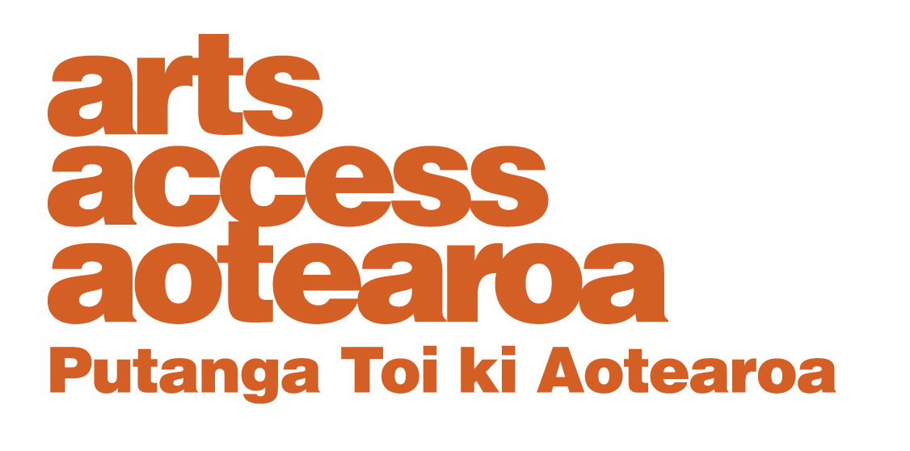
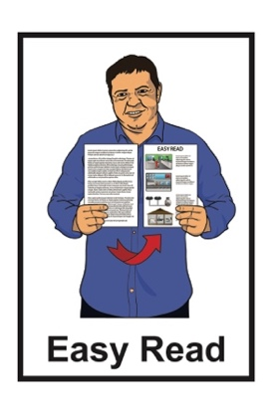

Arts for All Network

2025 Report
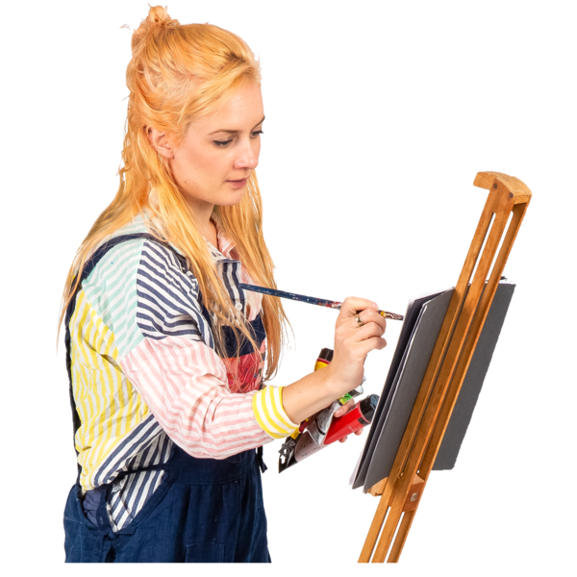

Published: August 2025

What this Easy Read is About

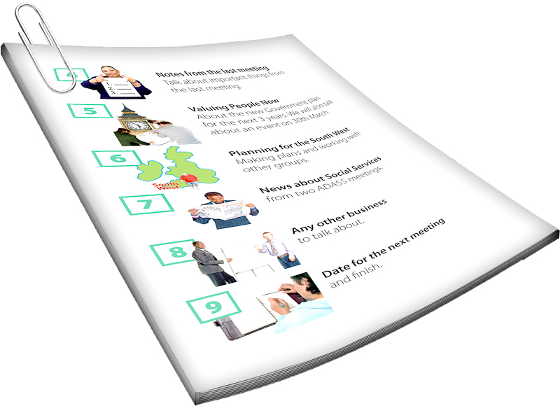
This Easy Read is from the Arts for All Network.

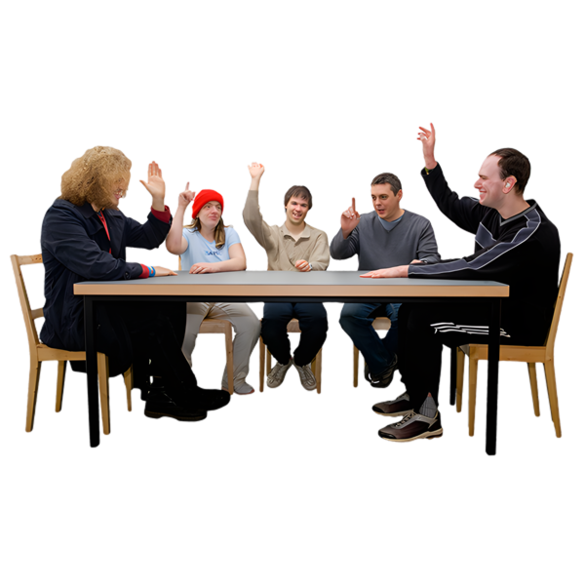
The Arts for All Network is for people who want to make the arts more accessible for:
deaf / Deaf people
disabled people.
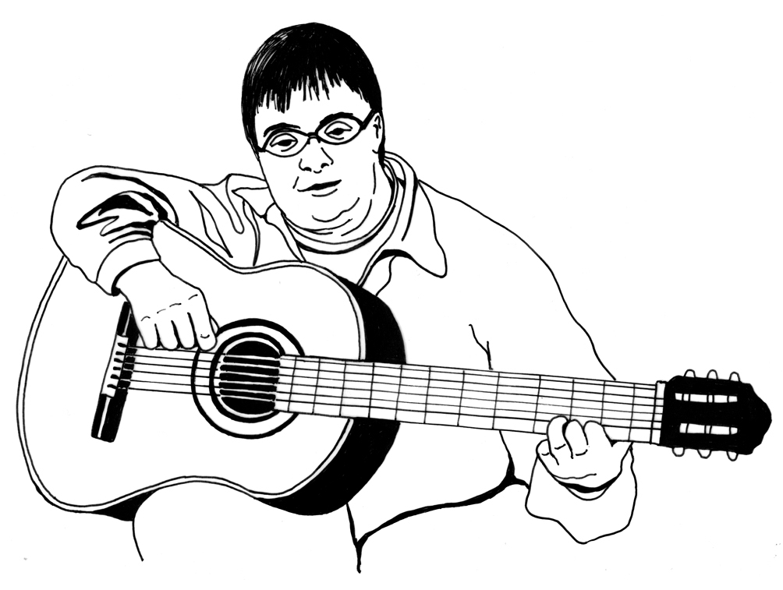

The arts includes things like:
music
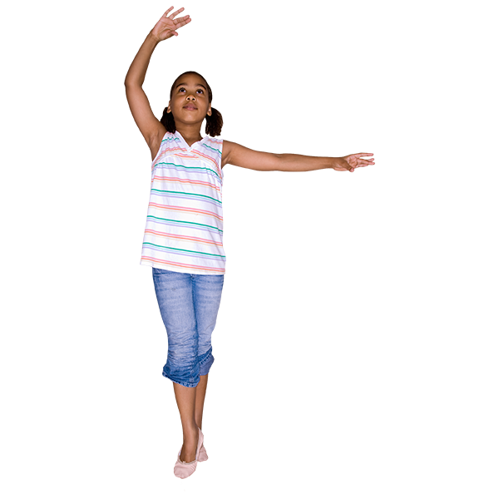
painting
dance
weaving.
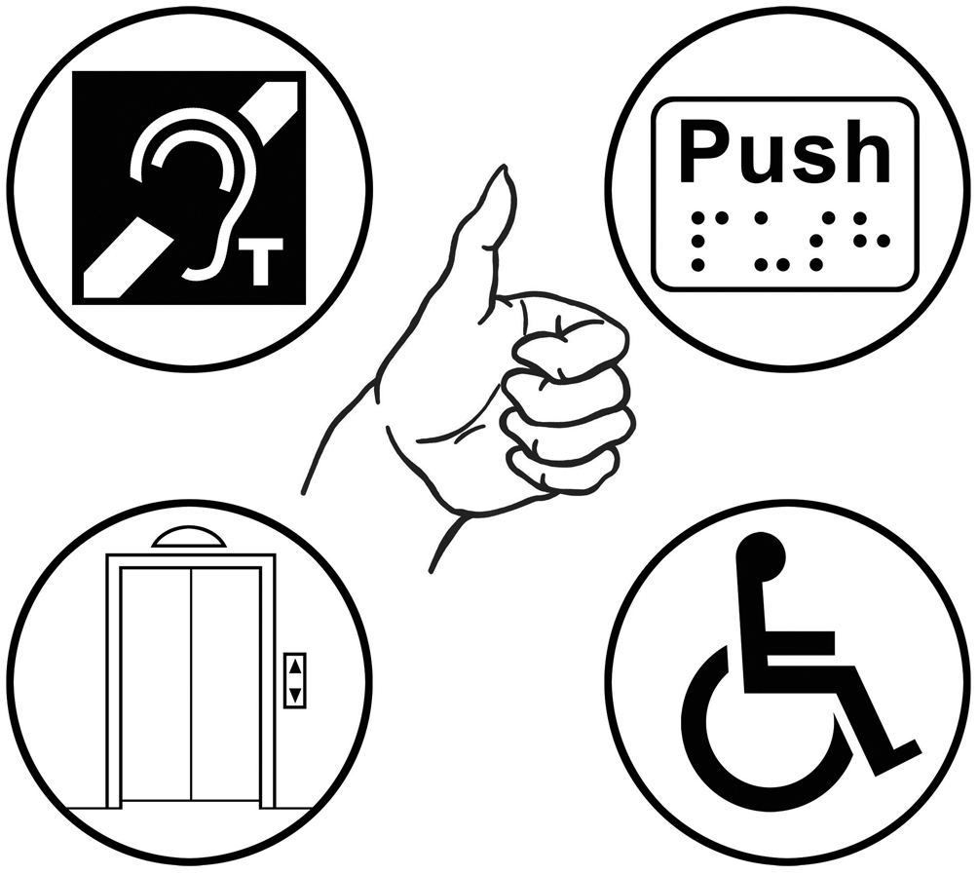
If something is accessible it means everyone is able to:
use it
take part.
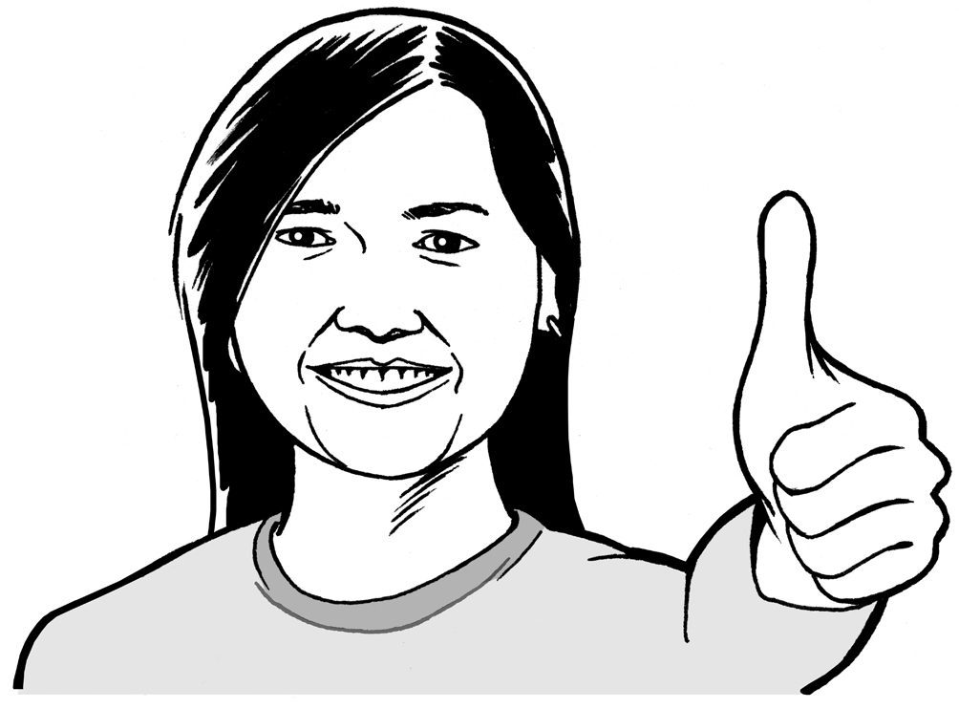

When you see we / us / our it means the Arts for All Network.

The Arts for All network is part of Arts Access Aotearoa.

Arts Access Aotearoa is an organisation that supports people so they can be part of the arts including:
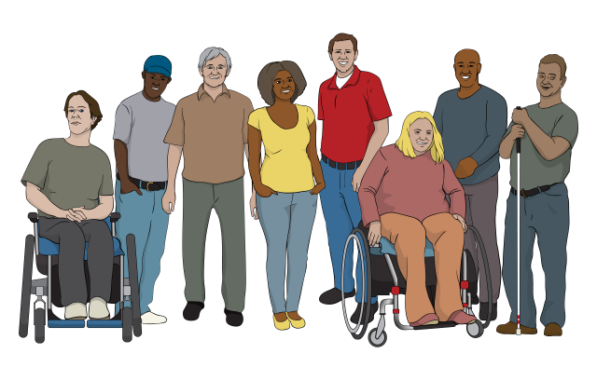
disabled people
Deaf communities
mental health communities.

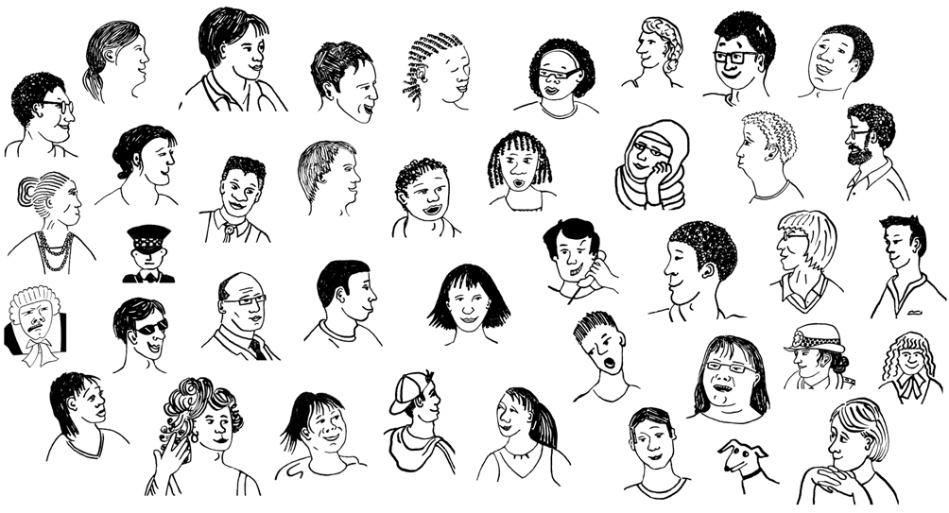
The Arts for All Network has about 1 thousand members around Aotearoa New Zealand.


Our members are both:
arts organisations
people who have something to do with the arts.
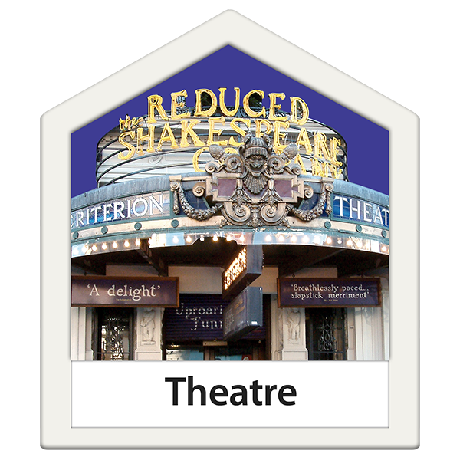

Many of our members are people who work in the arts like in:
theatres
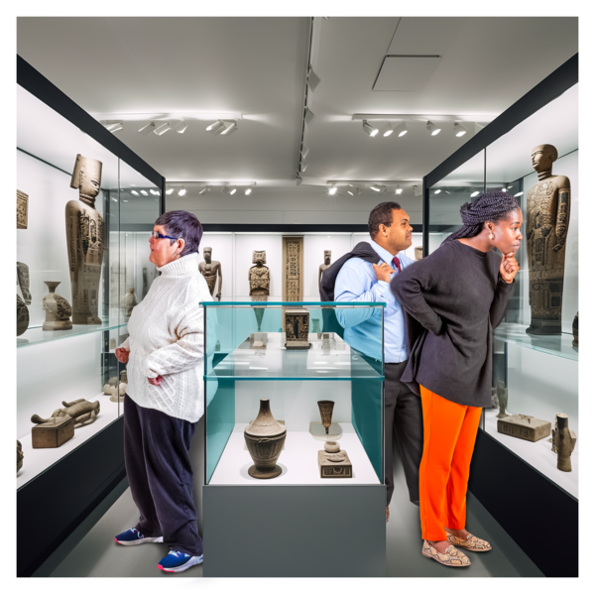
museums
art galleries.

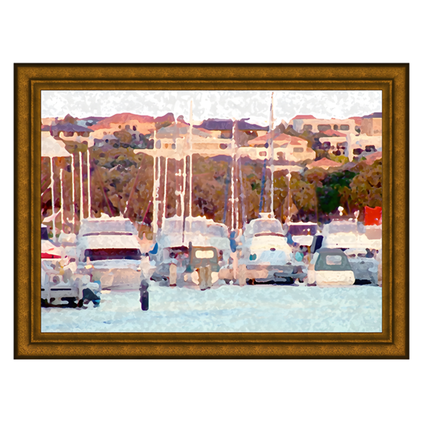
Some of our members are people who enjoy the arts like:
going to see shows
visiting art galleries.

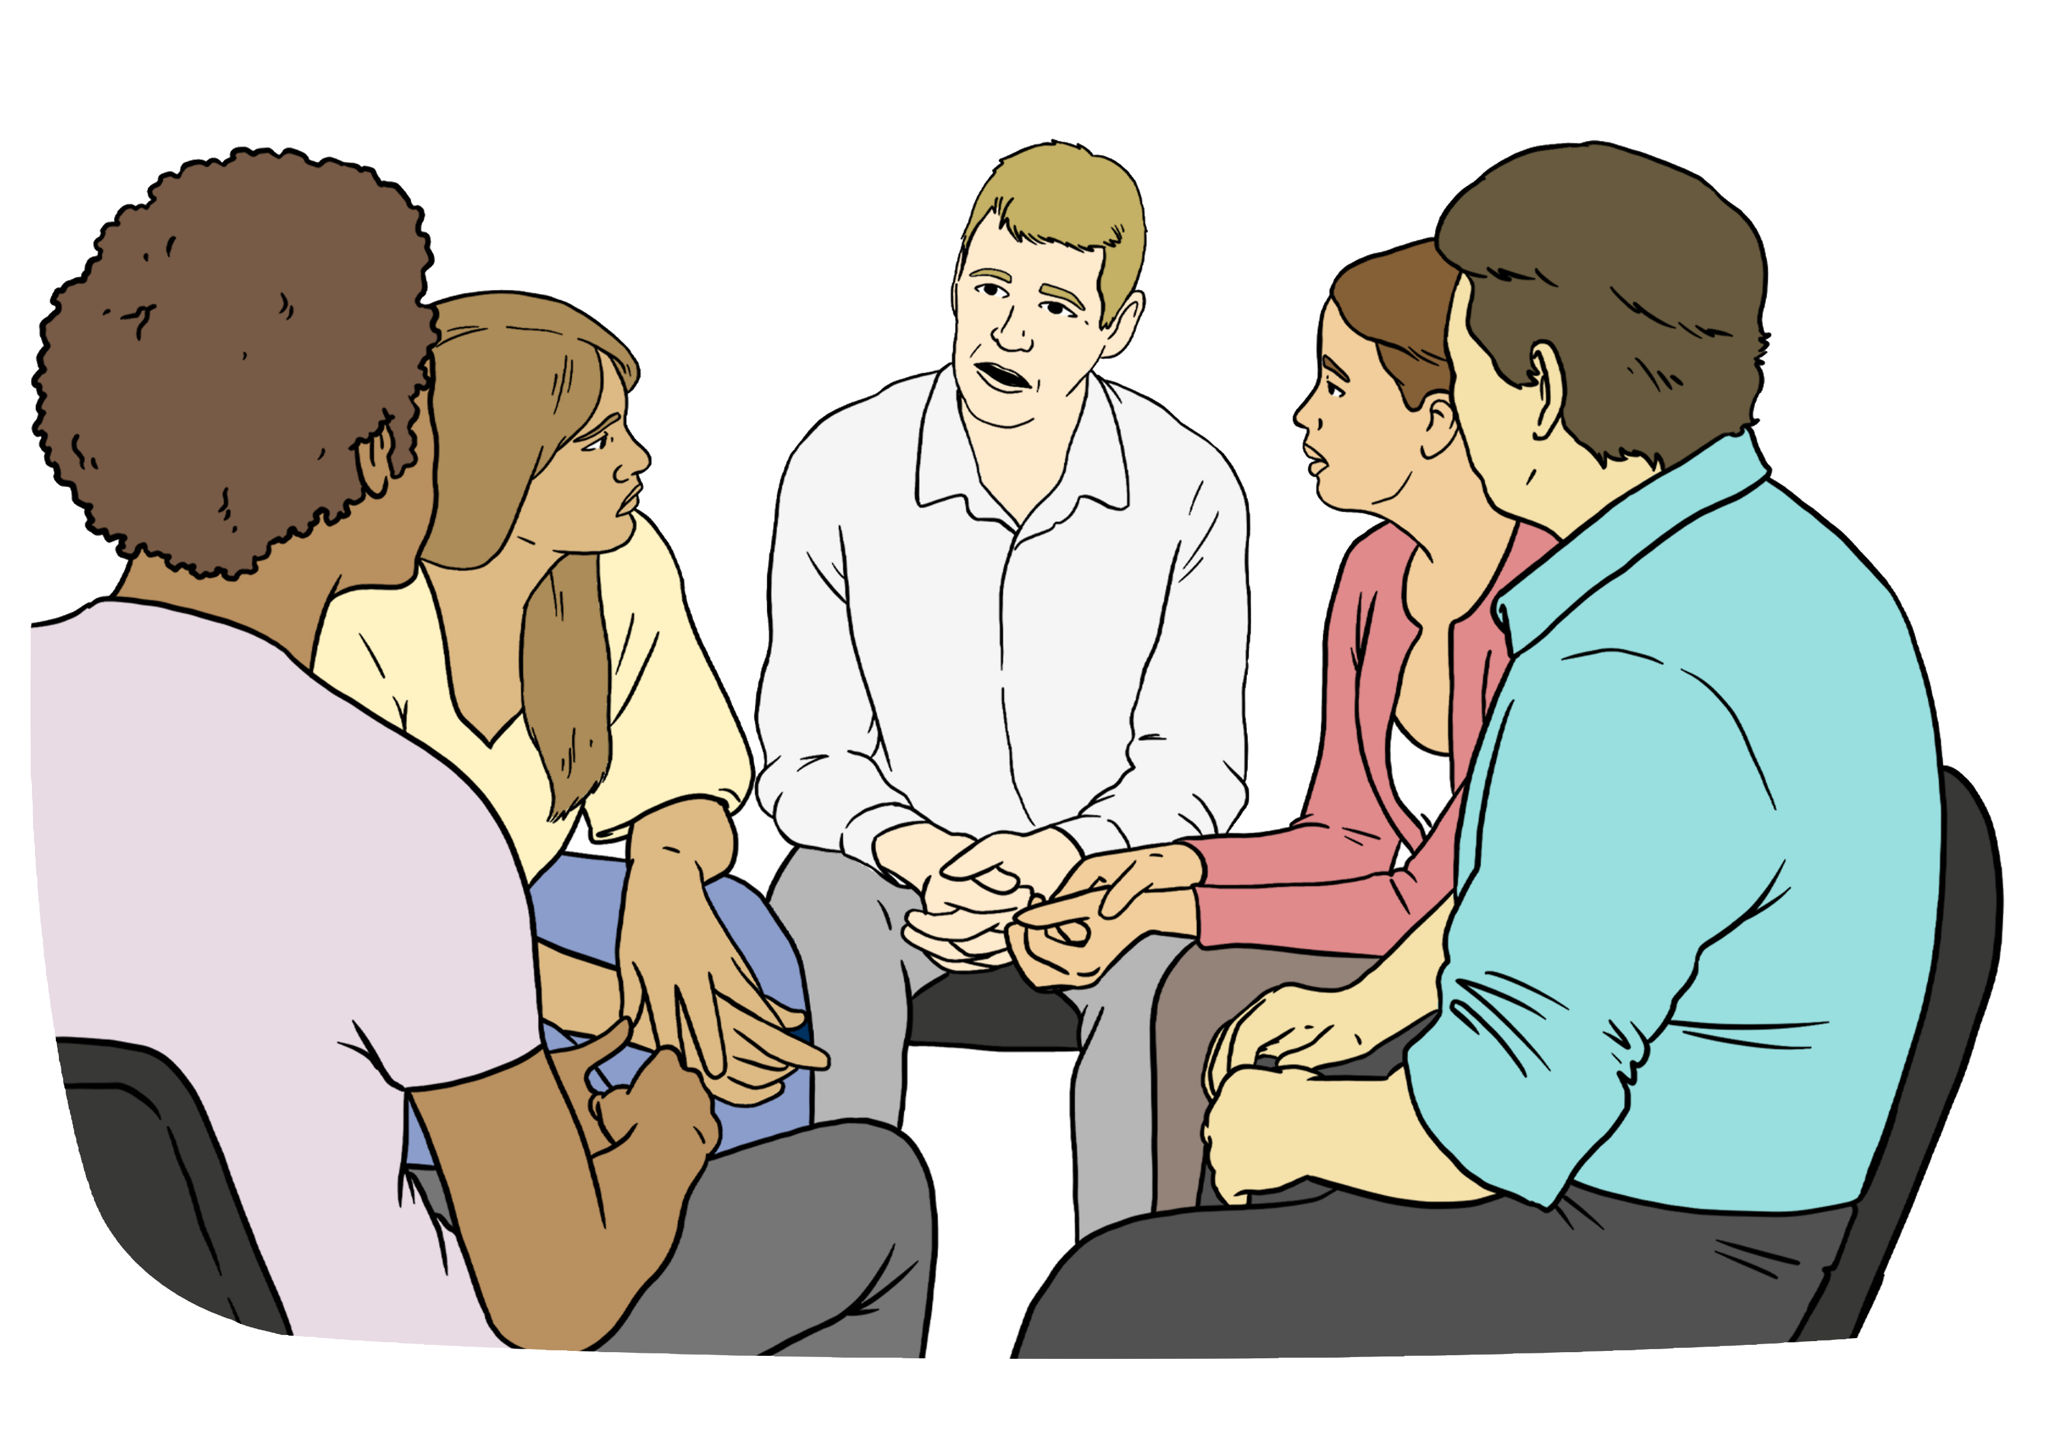
Our members can be:
disabled people
people who are not disabled.

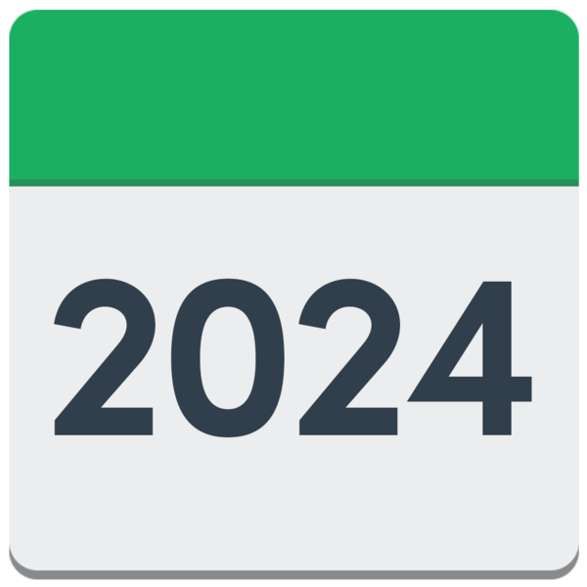
We wanted to know what our members did in 2024.

We also wanted to know what support our members need.
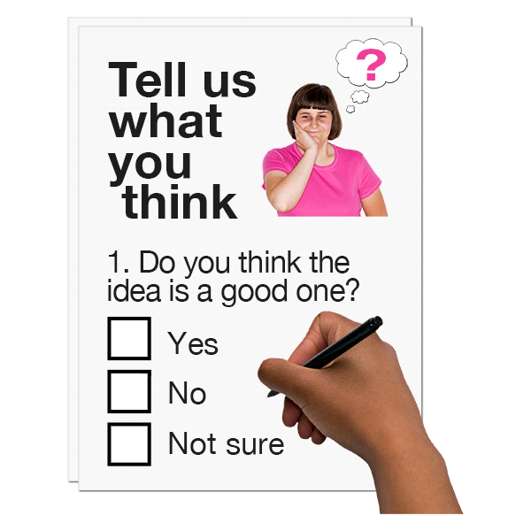

We sent a survey to all our members.
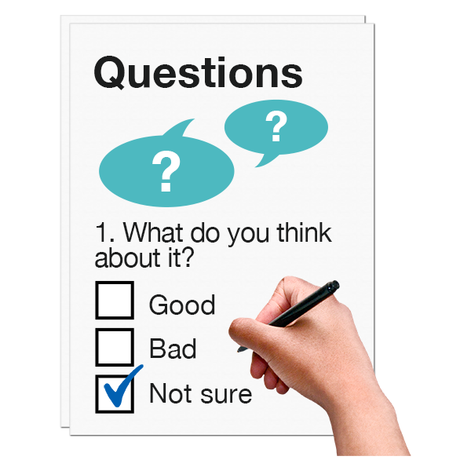
A survey is a way to get information by asking a lot of people to answer questions.

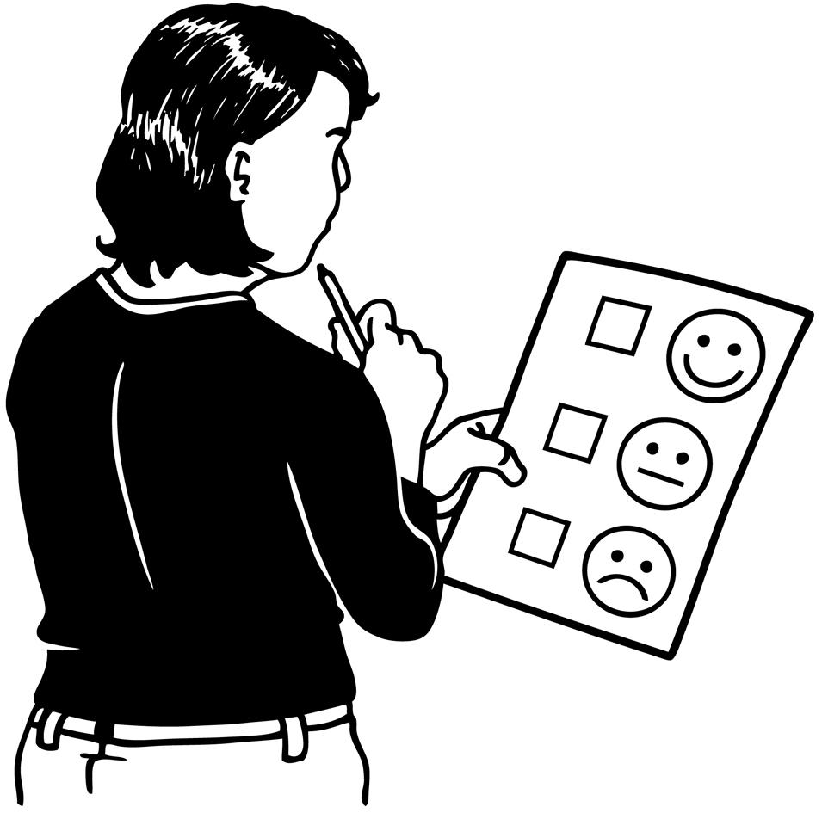
A lot of our members answered the survey.

In this Easy Read where you see members it means the members who answered the survey.

Nearly half the members who answered the survey are:
Deaf / deaf
disabled.
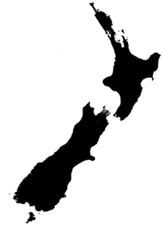

Members from all over Aotearoa New Zealand answered the survey.

What our members did in 2024

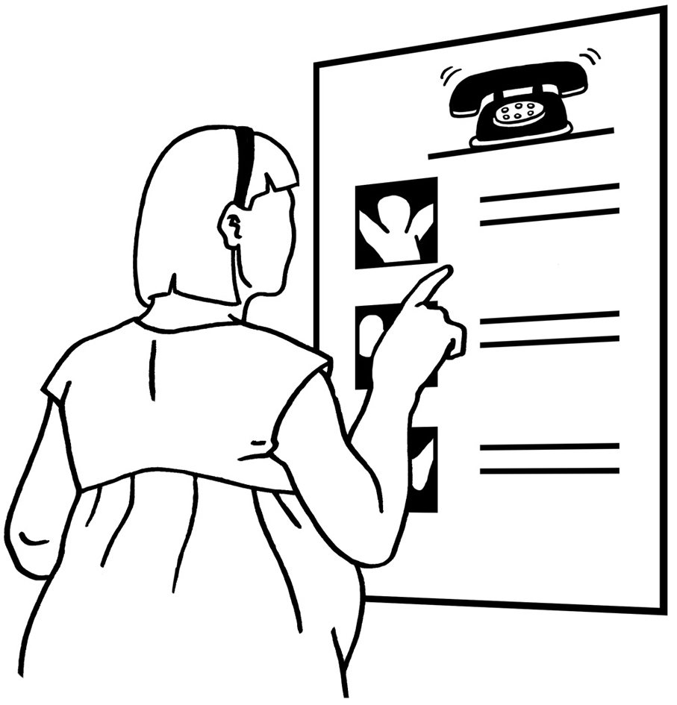
Around half of the members said they had done things in 2024 to make the arts more accessible like:
making signs
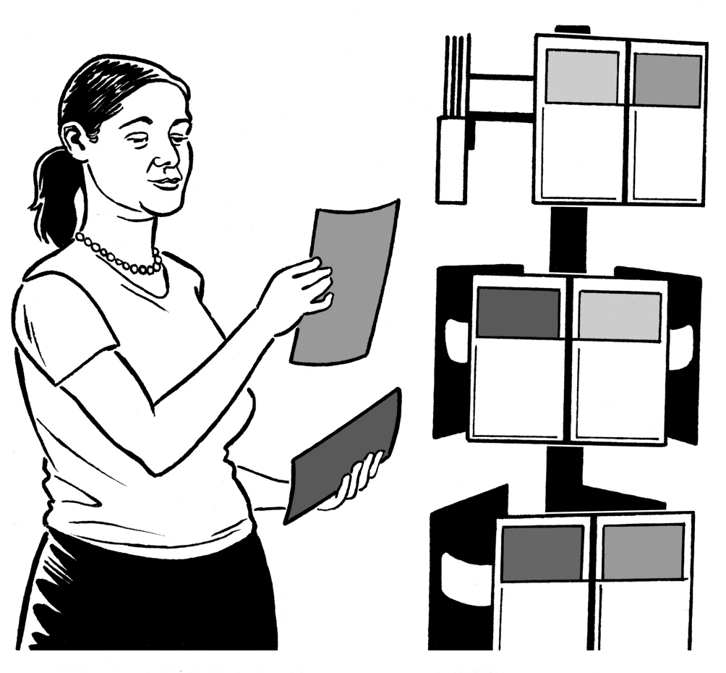
having information about what to expect at events.

Here events means things like:
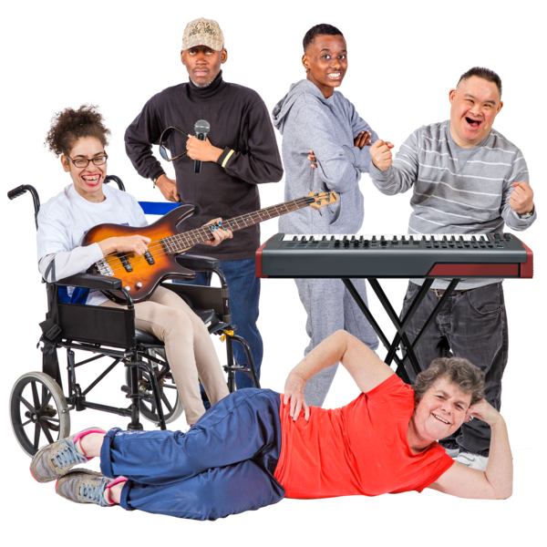
concerts
plays
art exhibitions.

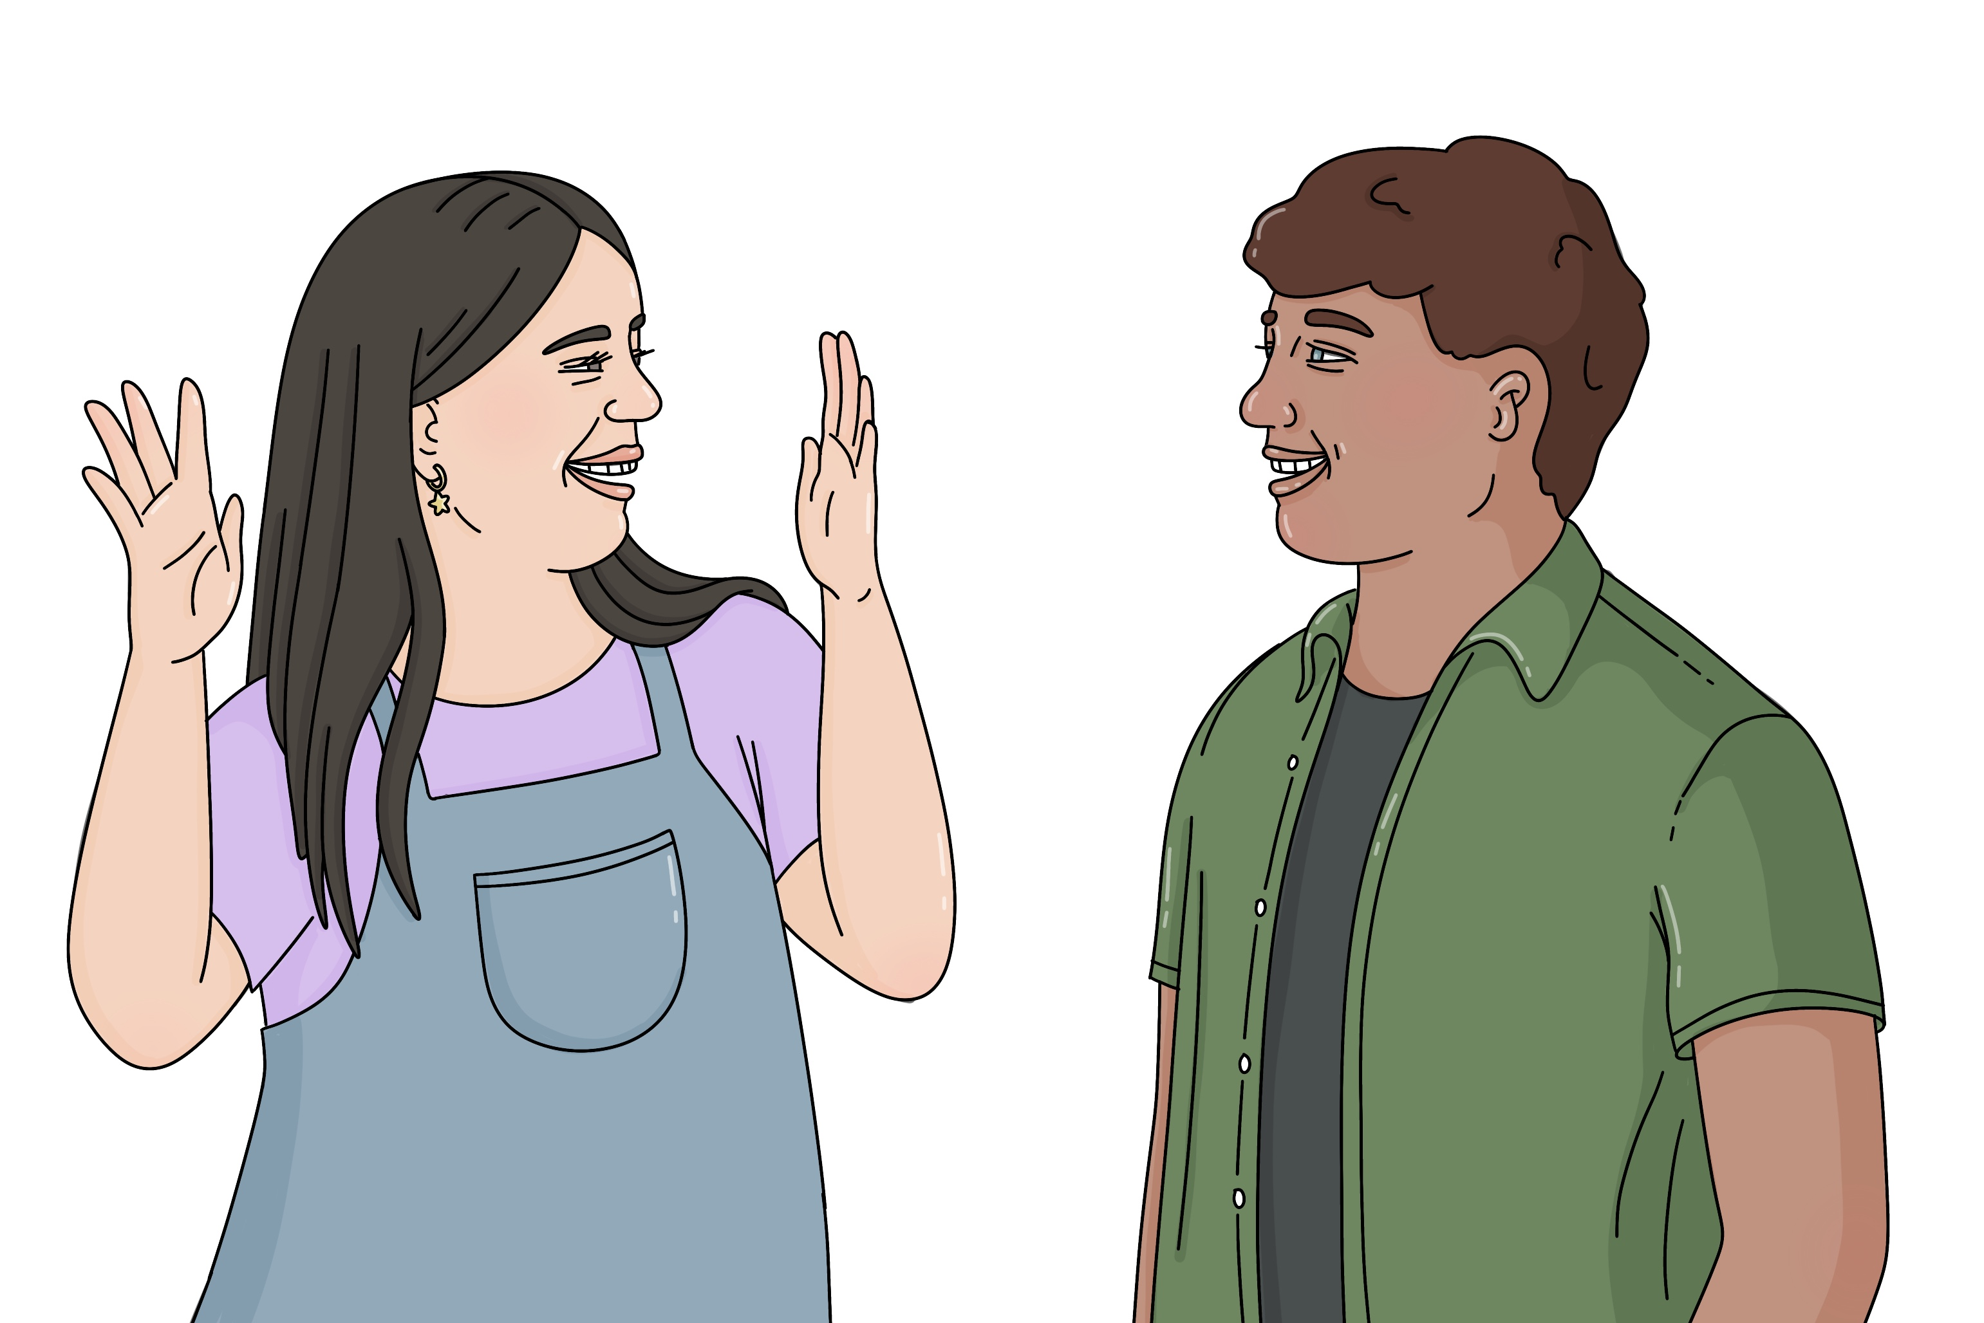
Around half the members had put on accessible events like:
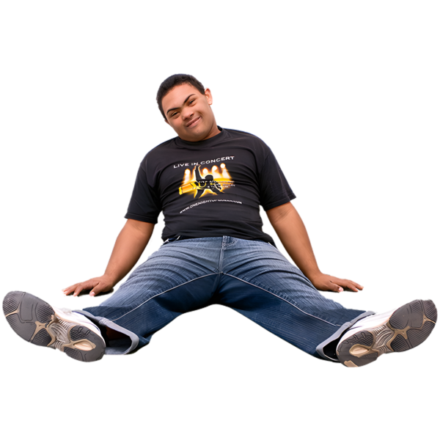
shows in New Zealand Sign Language
relaxed events.

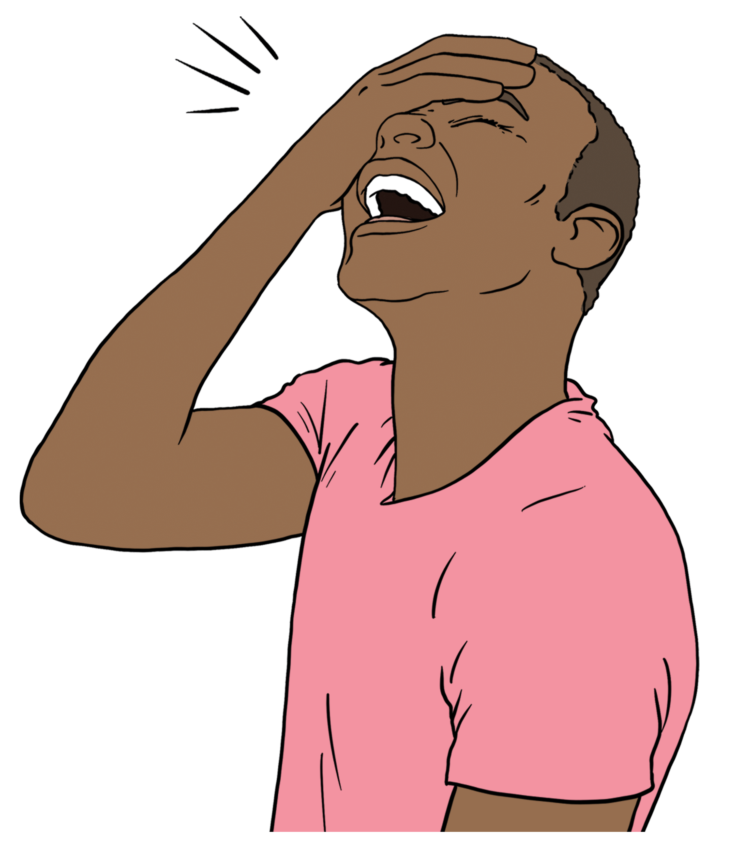
Relaxed events are events for disabled people where it is okay for the audience to:
move around
make noise

use things like:
- fidgets
- headphones.

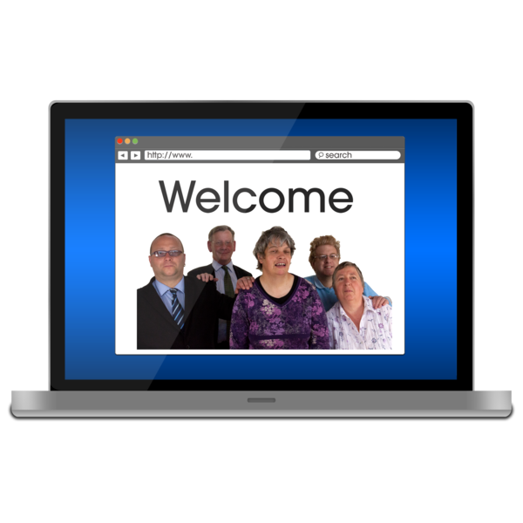
Around a quarter of members had made their websites better for disabled people.

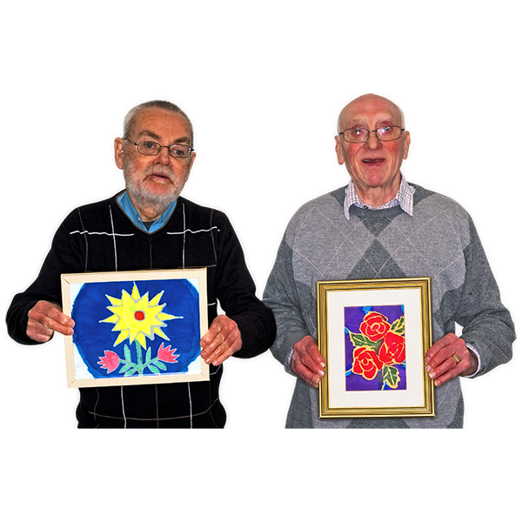
Over half the members worked with artists who are:
Deaf / deaf
disabled.

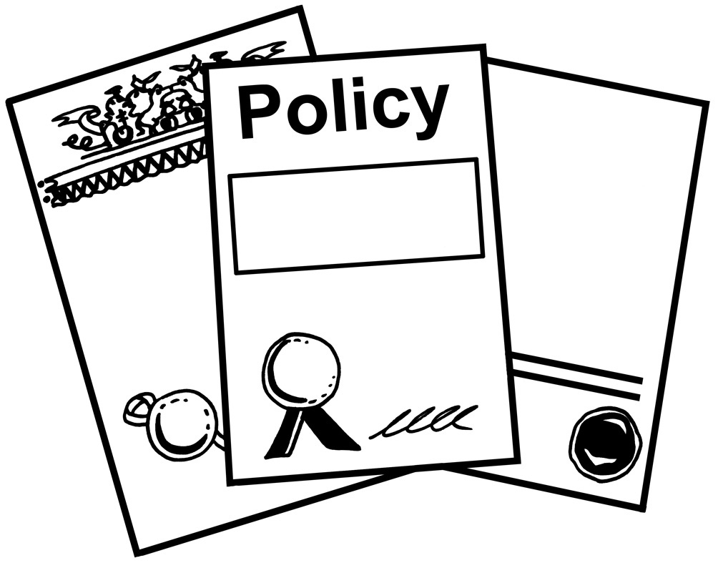
Around 3 quarters of members are writing an accessibility policy.

A policy is rules for an organisation to follow.


Almost 1 quarter of members changed how their team worked to be more accessible.

What was hard

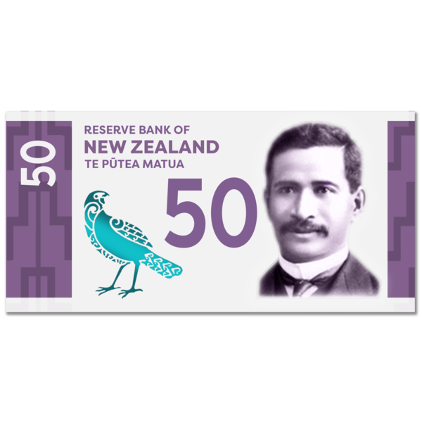
More than half the members said they did not have enough money.


Half the members said they did not have enough people to do the work.

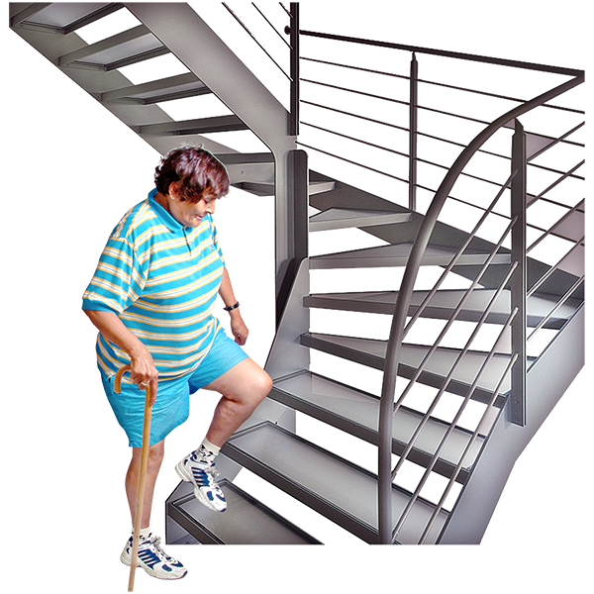
Some members work in buildings that are not accessible to:
visitors
artists.
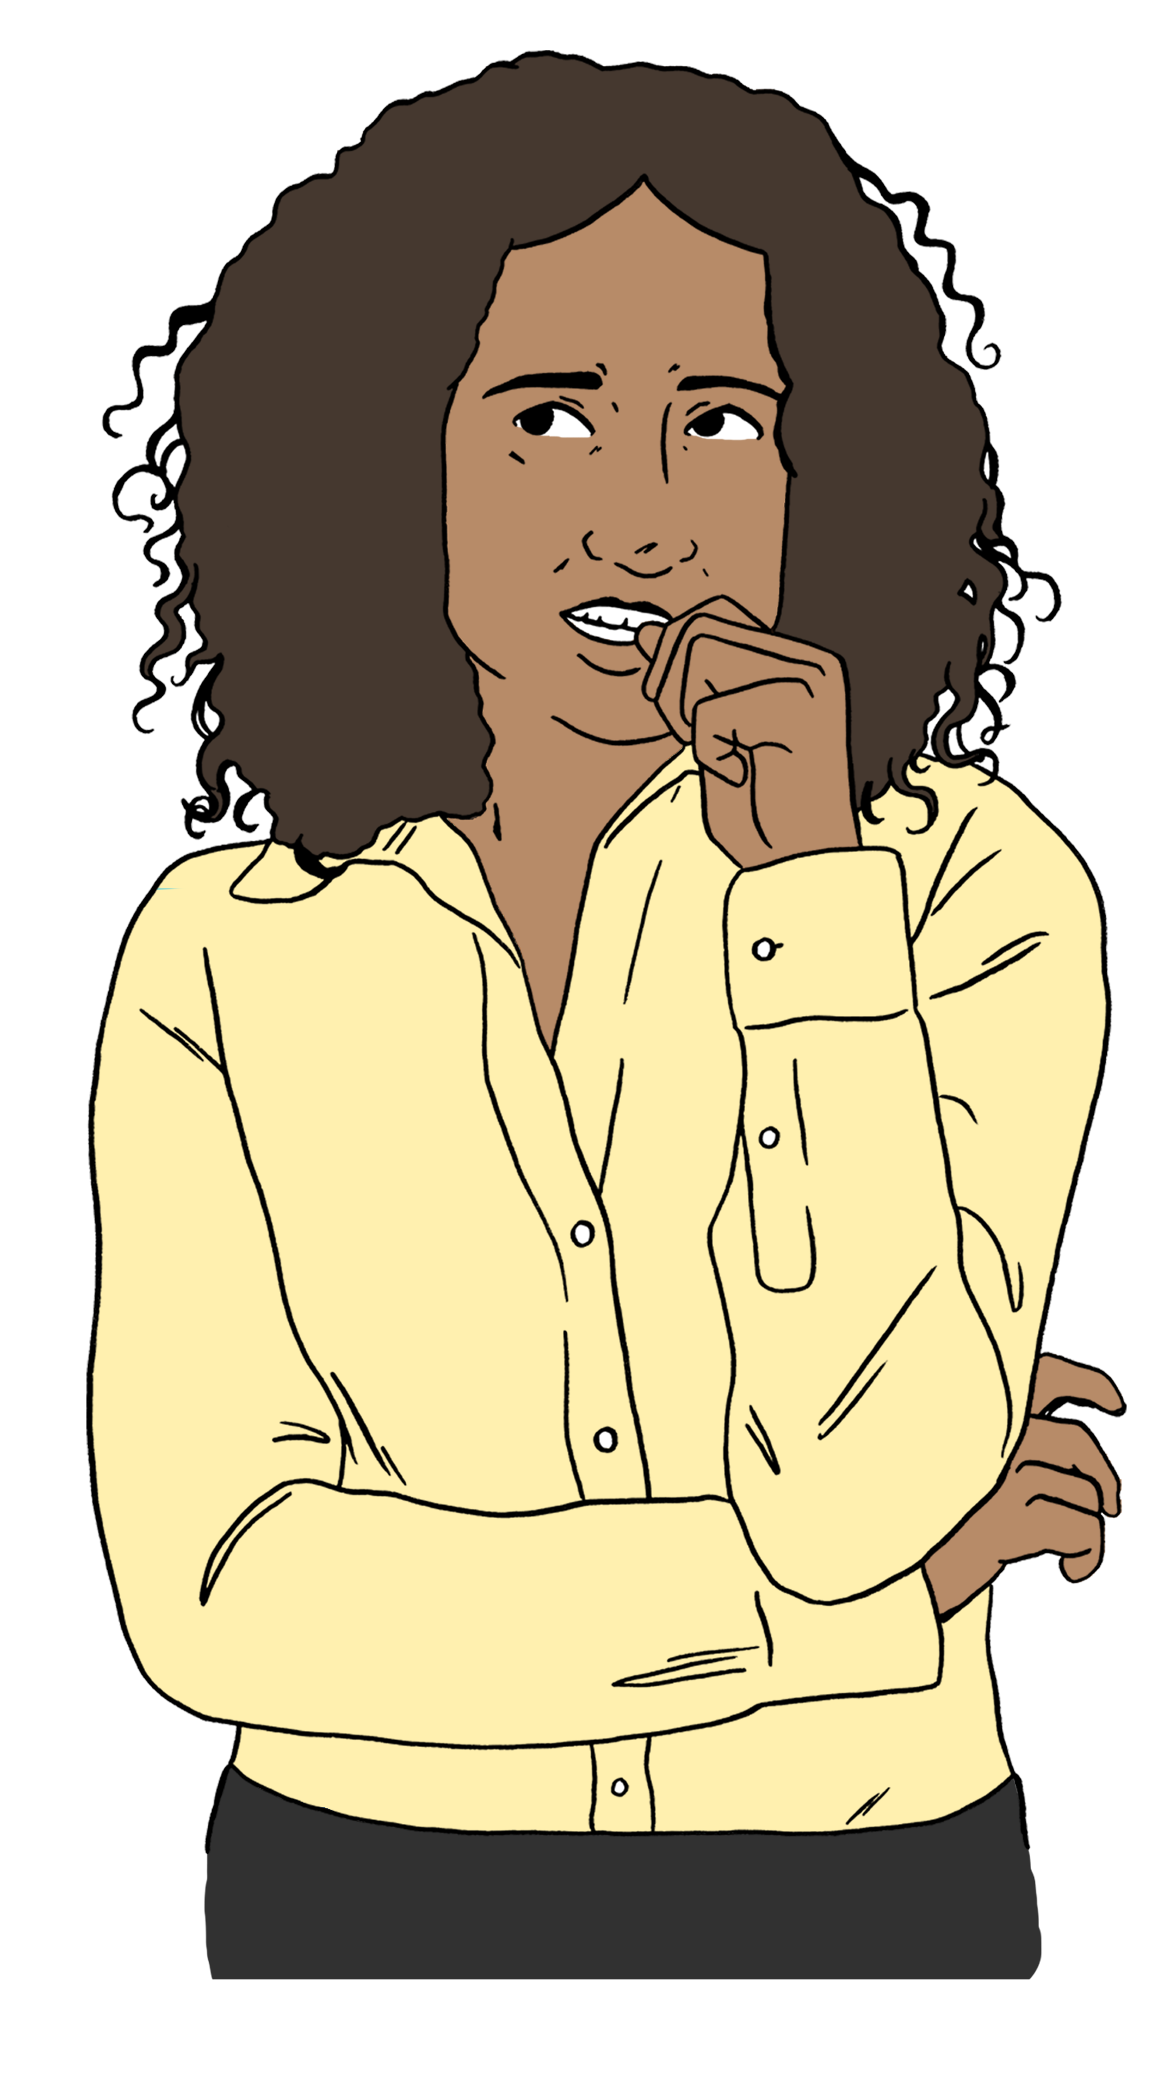

Some members said they:
do not know what to do
are worried they will make mistakes.
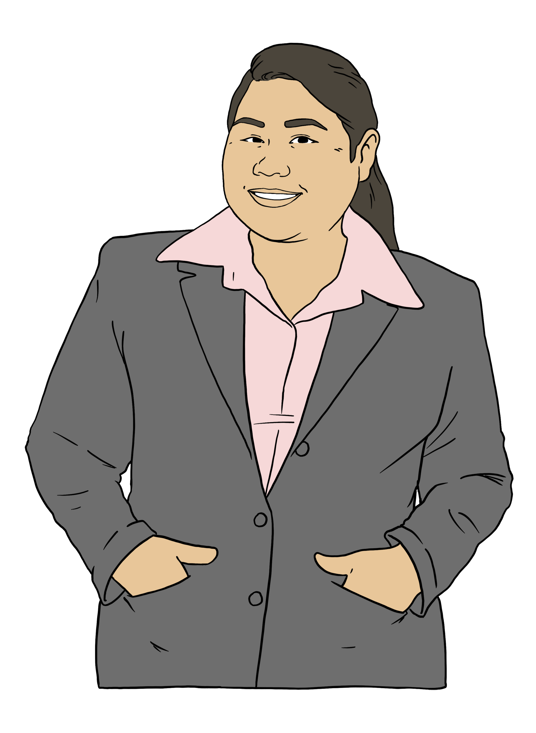
The members in some groups do not know anyone who is:
Deaf / deaf
disabled.
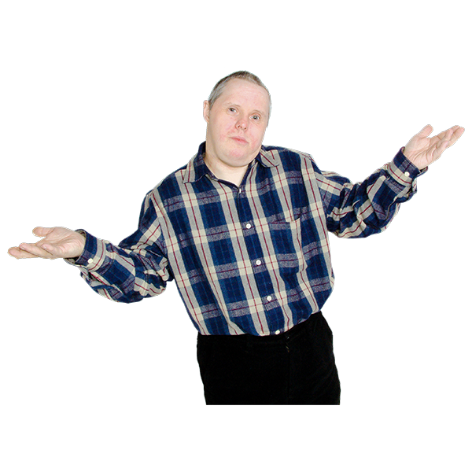

Some members said it is hard to get people to understand that accessibility is important.

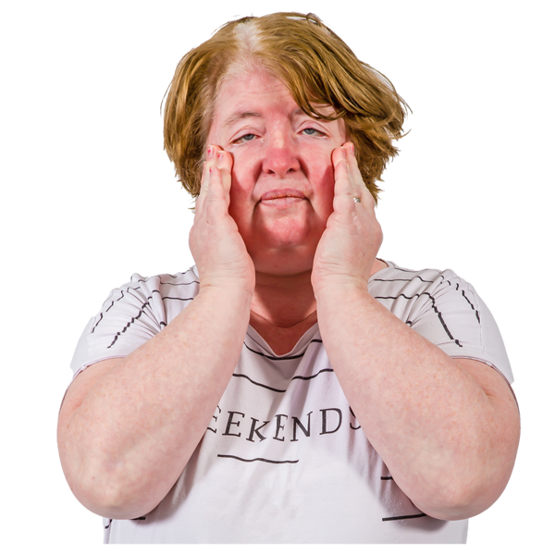
Disabled members said that it is tiring to do the work alone.

What members need

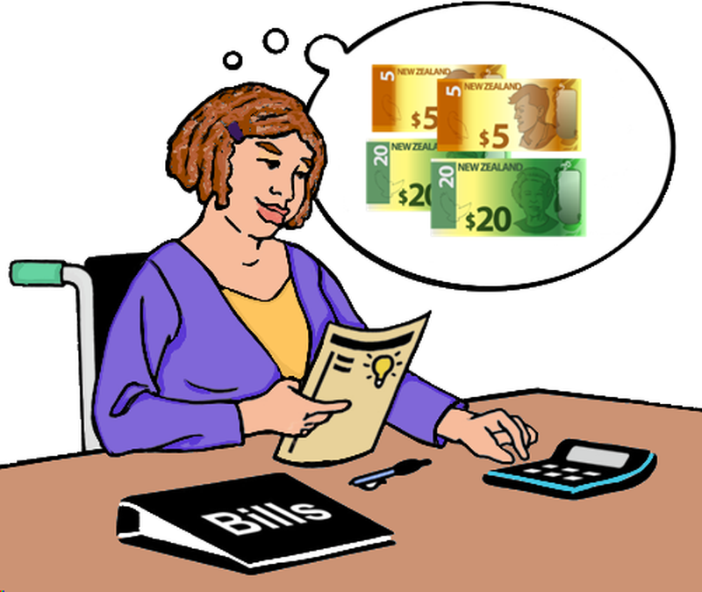
Members said they need support with:
budgets
grants.

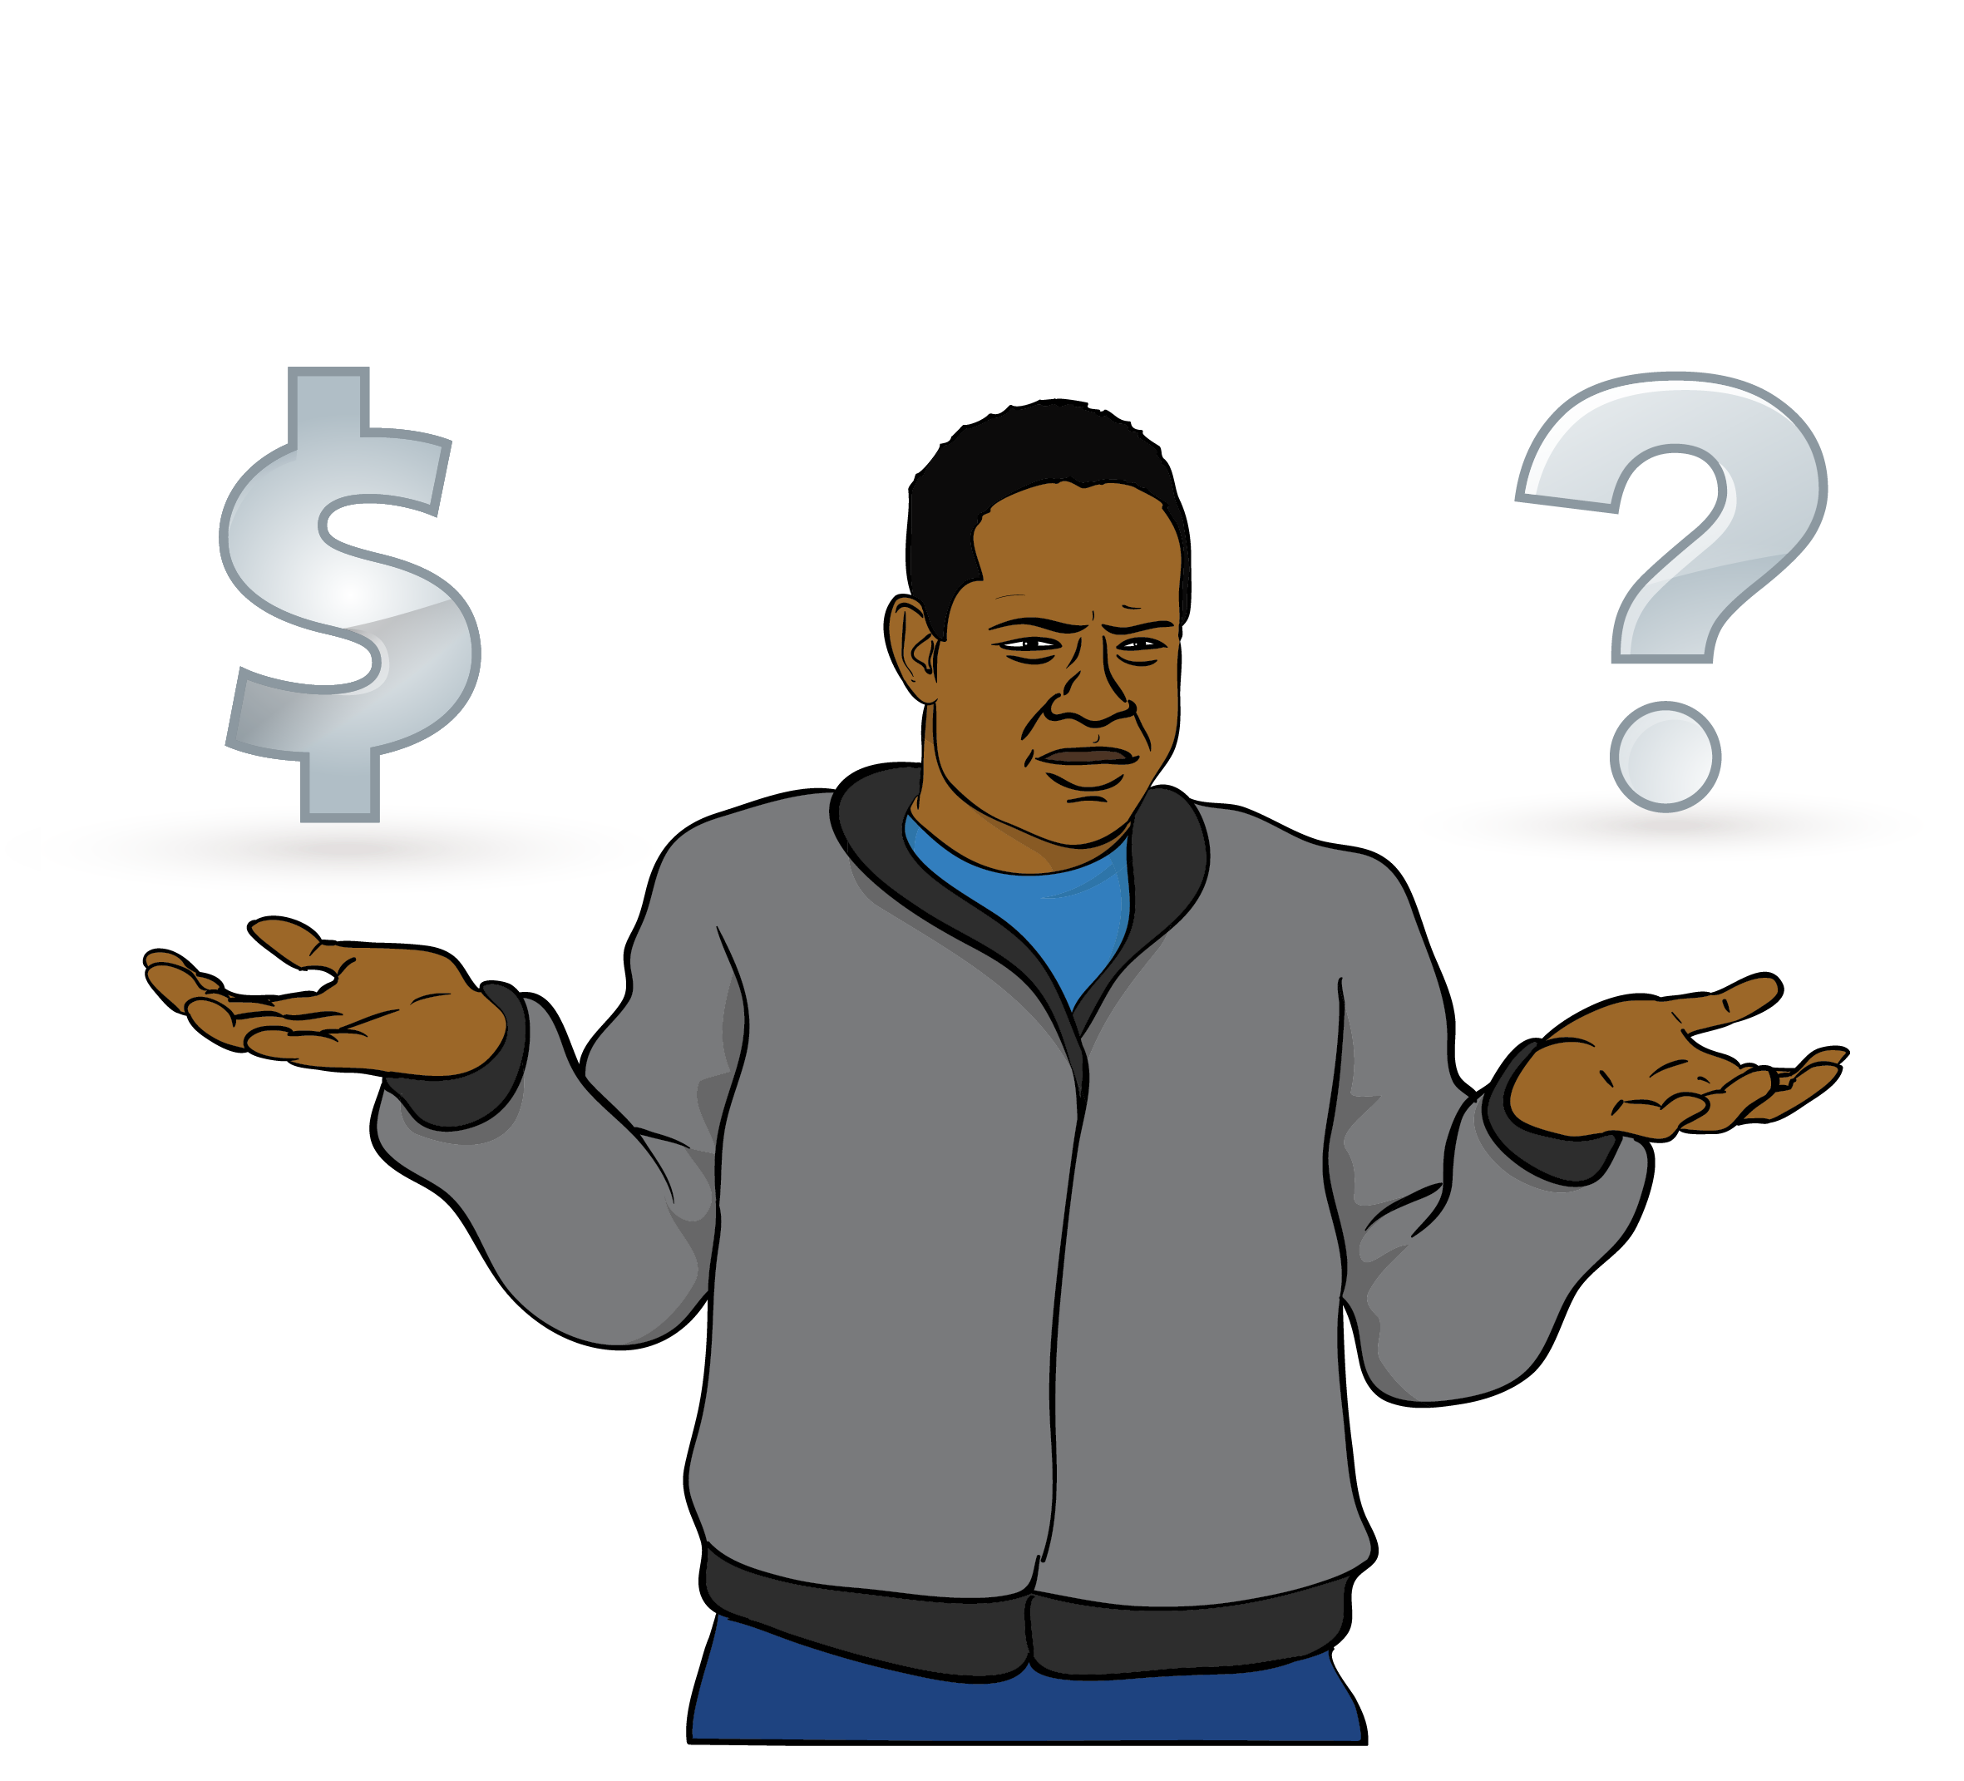
A budget is when you work out how much money you will:
get
spend on different things.

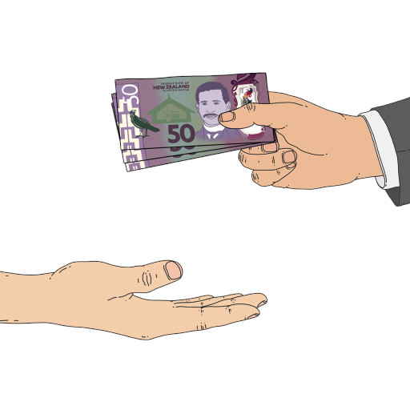
Here grants are money an organisation can get to support it with its work.

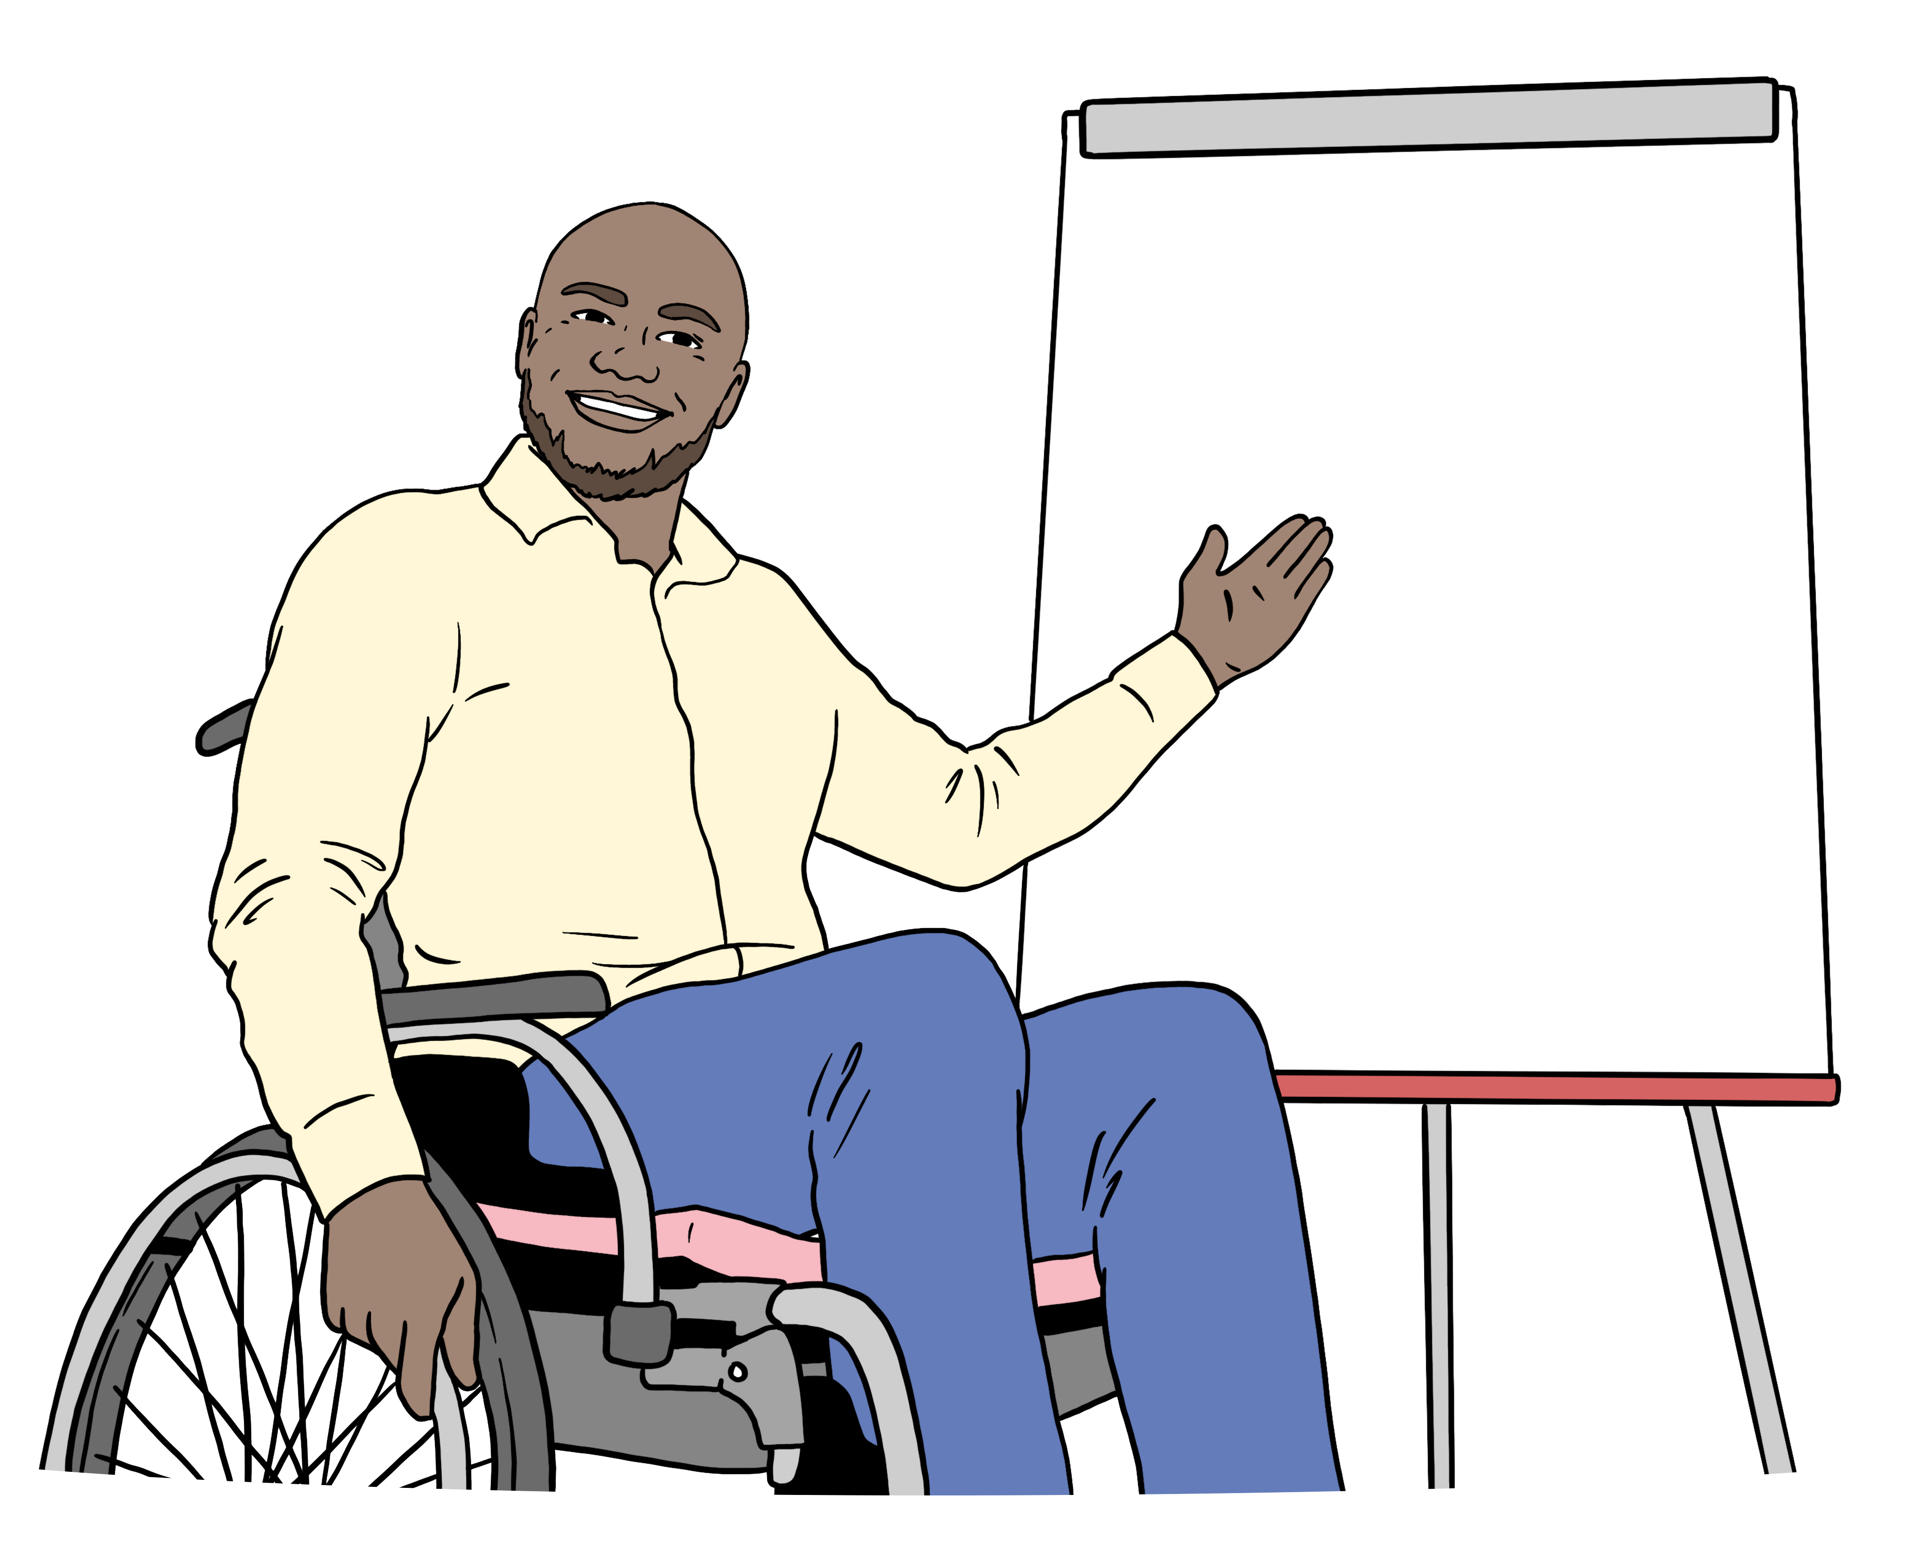
Members who did not live in big cities said they needed more:
training
support.

Members said they needed support to make accessibility:
plans
policies.

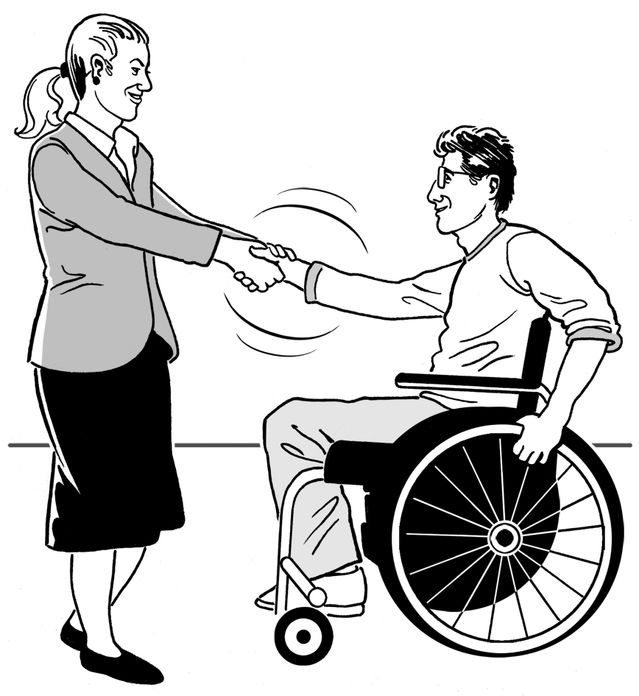
Members said they needed to find better ways to:
get to know artists
work with artists.

What members hope for

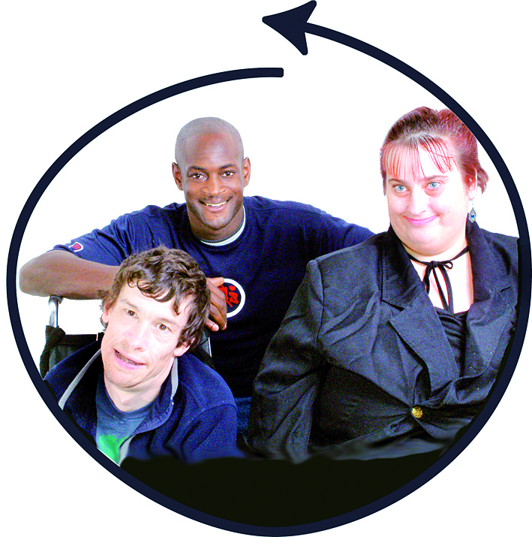
Members hoped there would be more events that everyone can go to.

They wanted more of the people in charge of arts events / organisations to be:
Deaf / deaf
disabled.


Members wanted good information about:
accessibility
what events / places would be like.

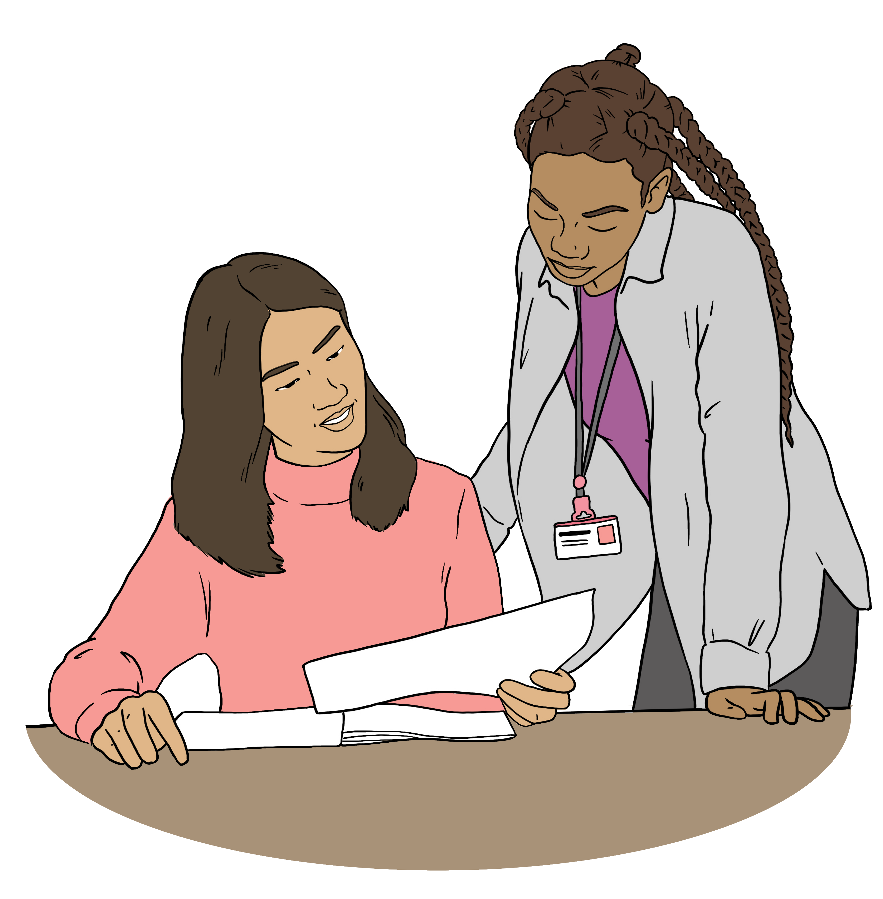
They wanted this information to be easy to:
read
understand.
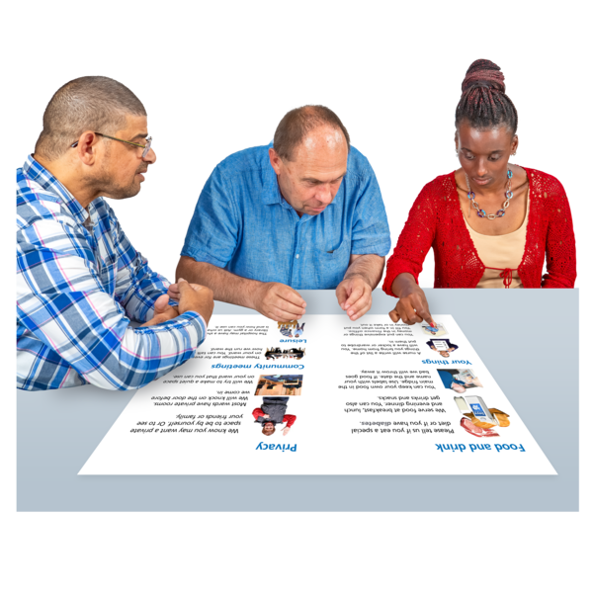

Members hoped that arts organisations would do more work with disabled people.

Members said they need more money to make these changes.

What Arts Access Aotearoa are doing
in 2025
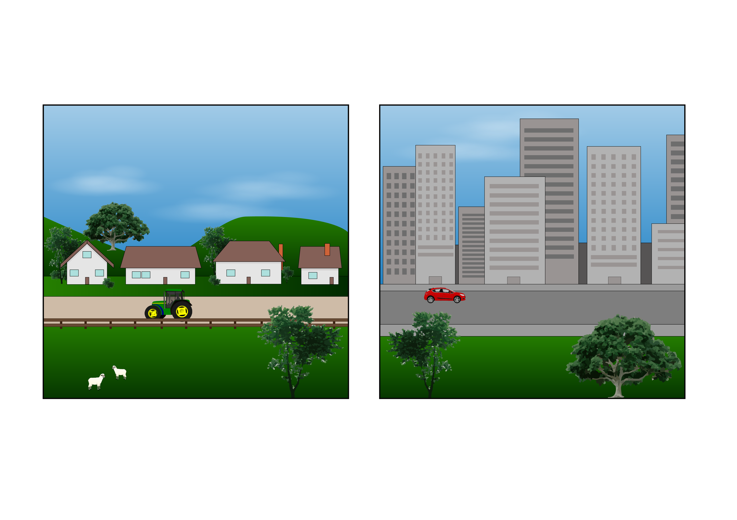

Arts Access Aotearoa are visiting more places that are outside of big cities.


They are running online meetings for members every month.

Having online meetings means that people who cannot go to a meeting in person can still join in.

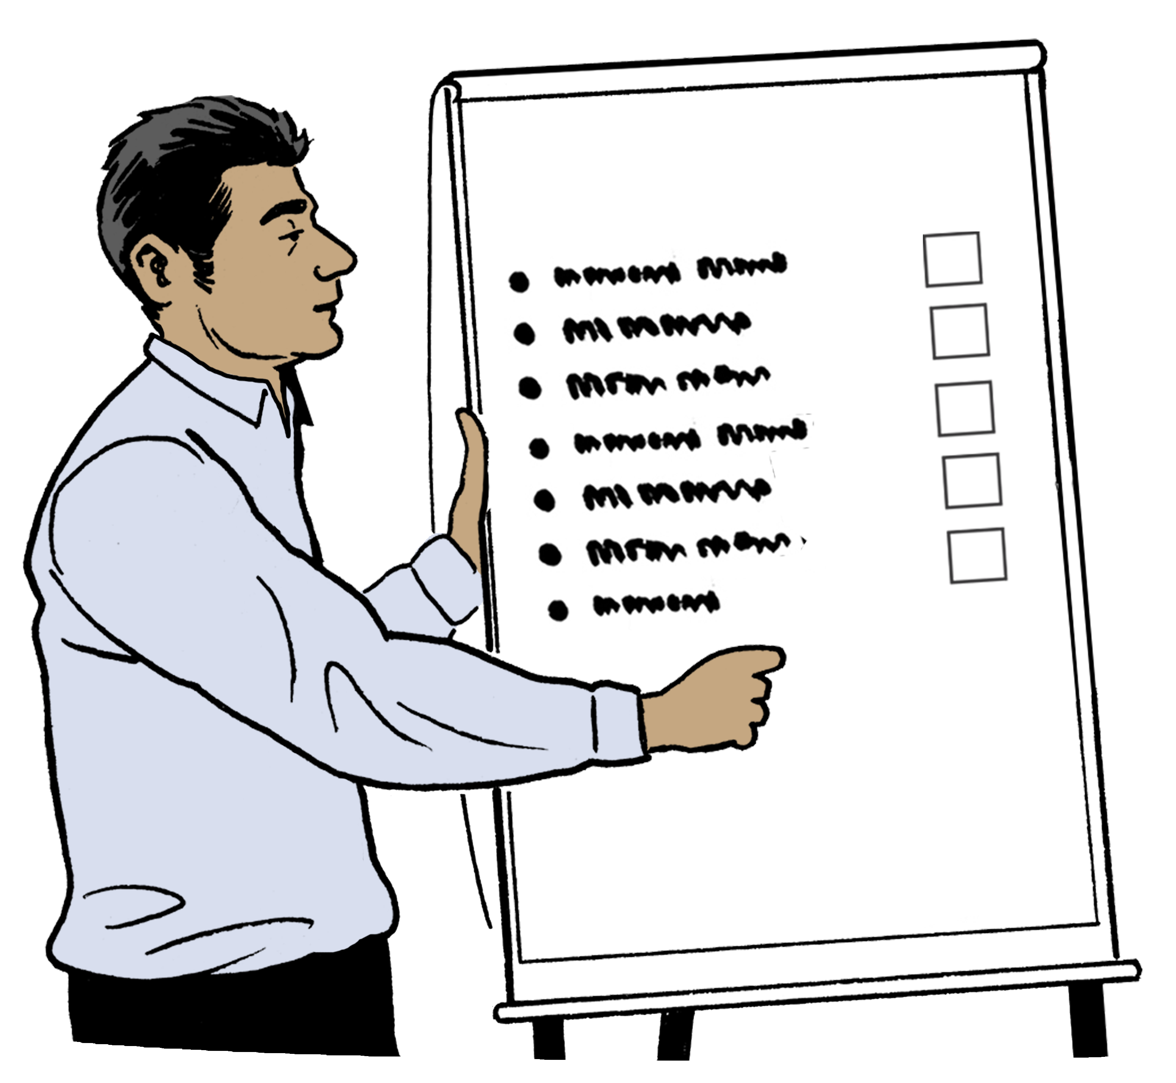
Arts Access Aotearoa are making new:
resources like information about running accessible events
training for memebers.


Arts Access Aotearoa have started Taha Hotu for artists who are:
Deaf / deaf
disabled.

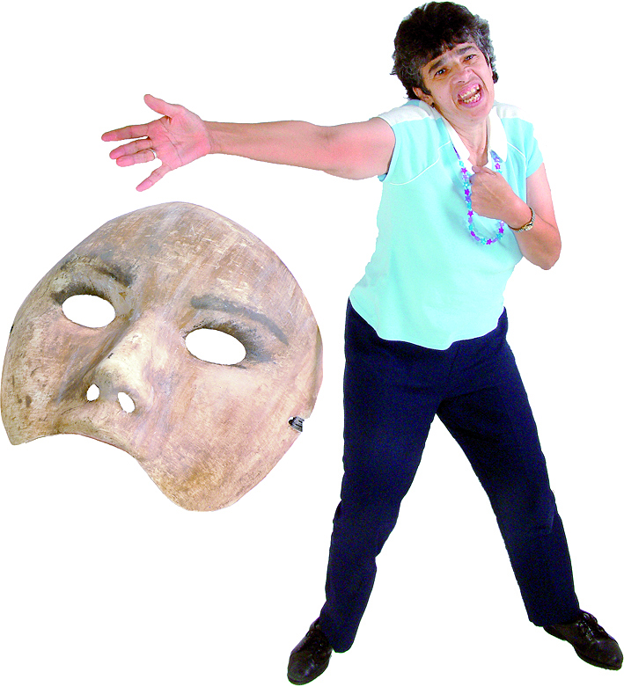
Taha Hotu makes it easier for artists to work:
together
with organisations that can support them.

How to get in touch with us

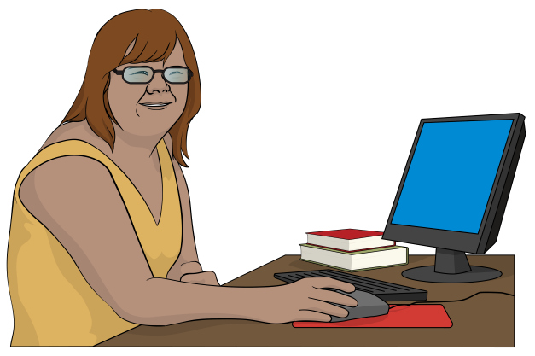
You can email the Art for All Network at:

afa@artsaccess.org.nz

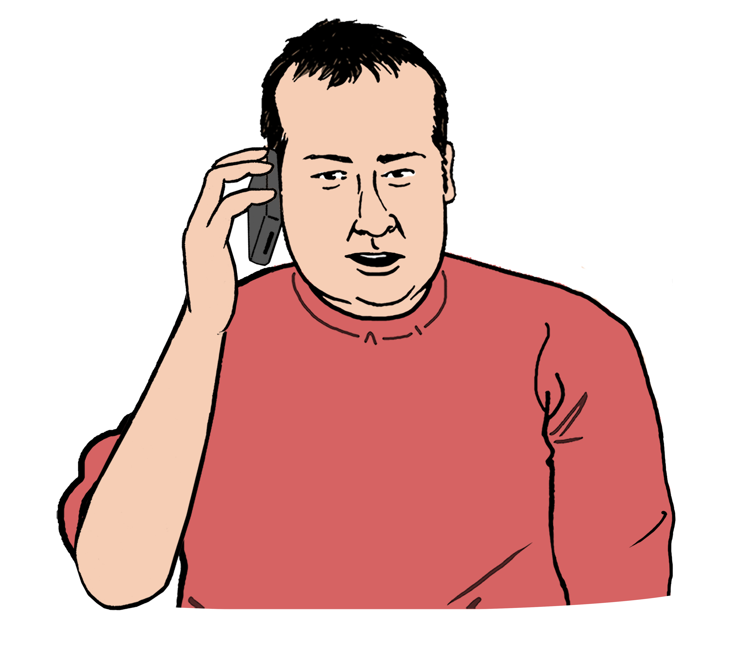
You can phone us on:

04 802 4349

It may cost money to phone this number.
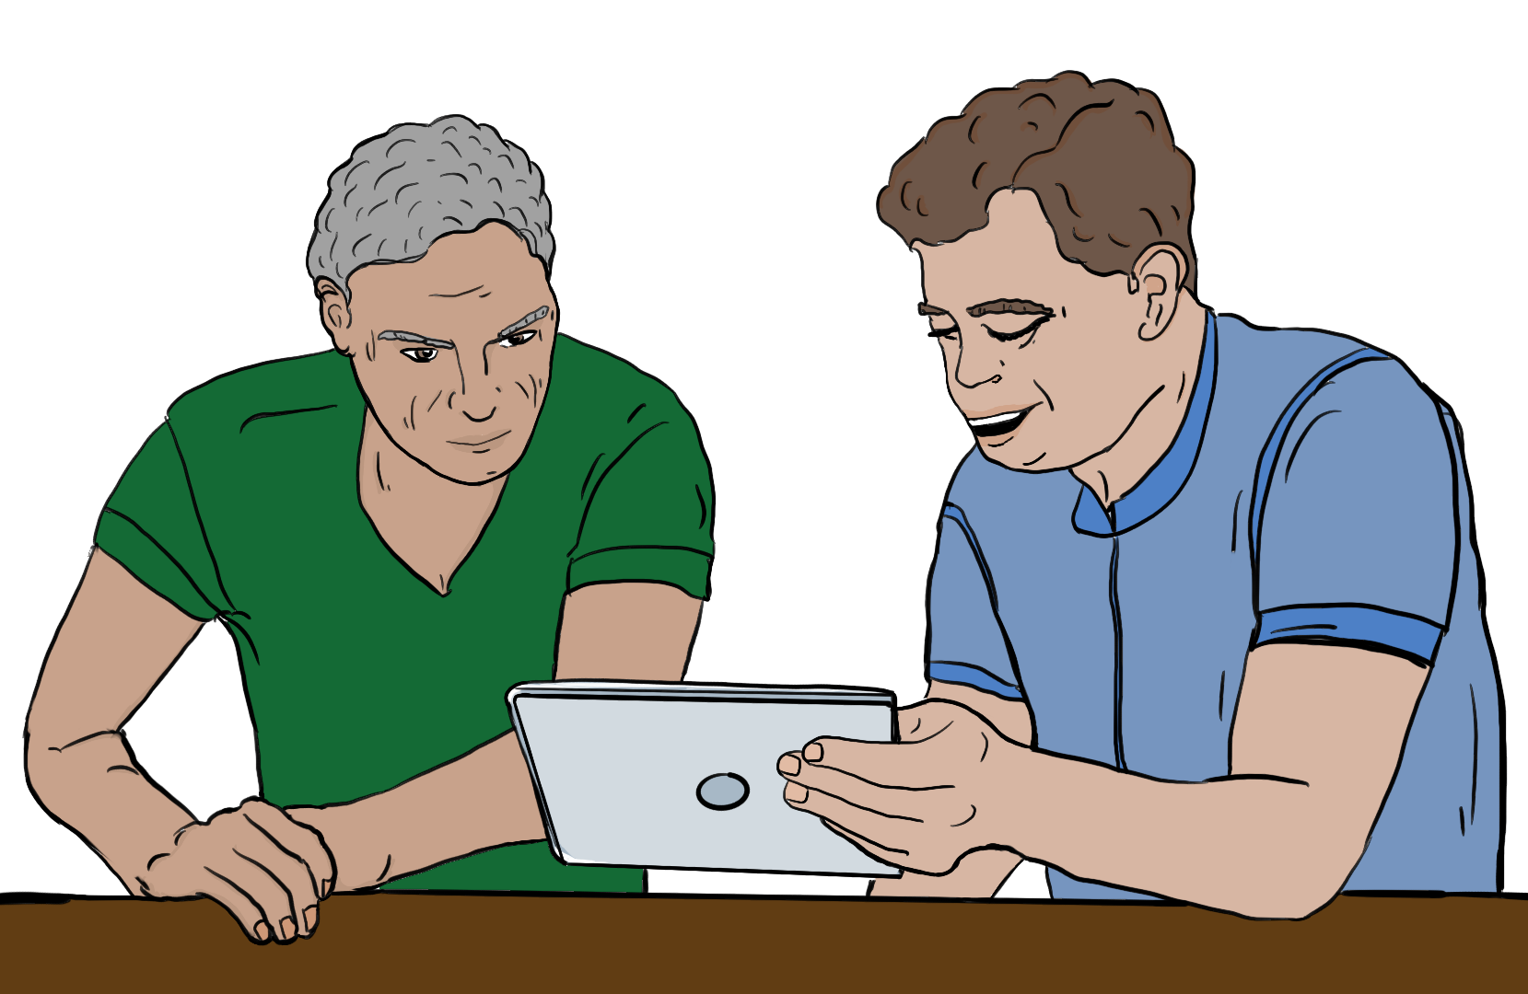

Our website is at:

www.artsaccess.org.nz

This information has been written by Arts Access Aotearoa

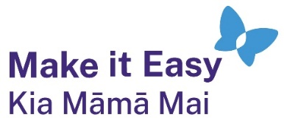
It has been translated into Easy Read by the Make it Easy Kia Māmā Mai service of People First New Zealand Ngā Tāngata Tuatahi.
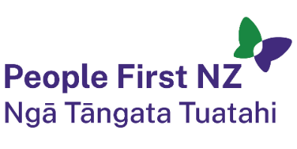
The ideas in this document are not the ideas of People First New Zealand Ngā Tāngata Tuatahi.

All images used in this Easy Read document are subject to copyright rules and cannot be used without permission.

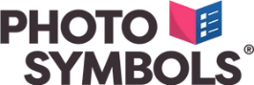
Make it Easy uses images from:

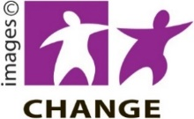
- Photosymbols

- Change Images

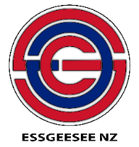
- Huriana Kopeke-Te Aho
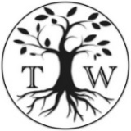
- SGC Image Works

- T Wood

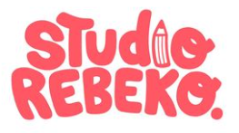
- Studio Rebeko

- Inga Kramer.

