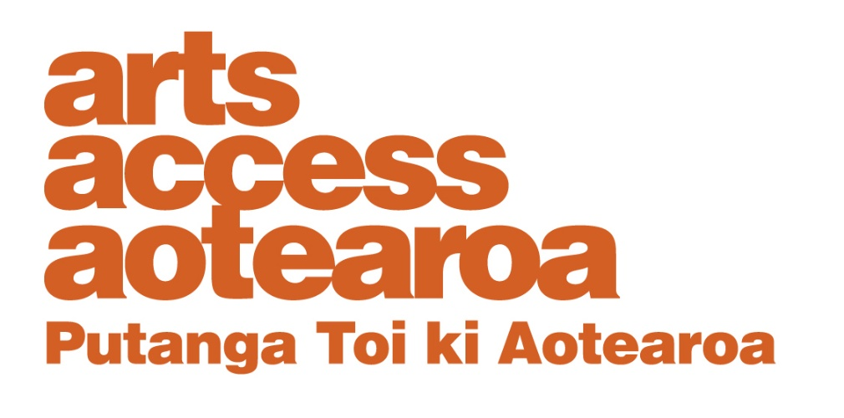
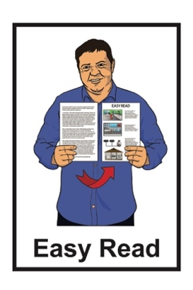

About the
Arts For All Network
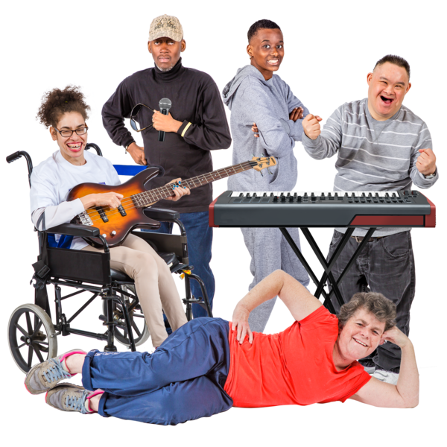

Published: November 2025

About this Easy Read

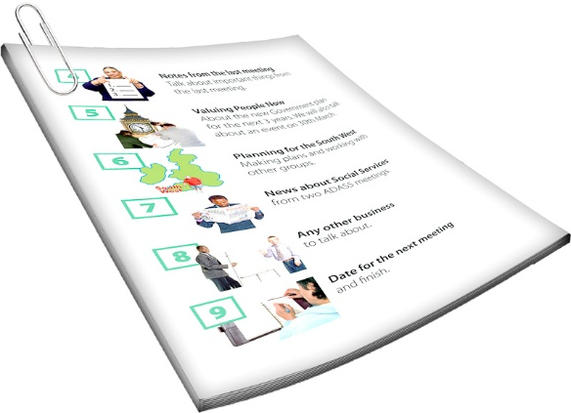
This Easy Read is about the Arts For All Network.

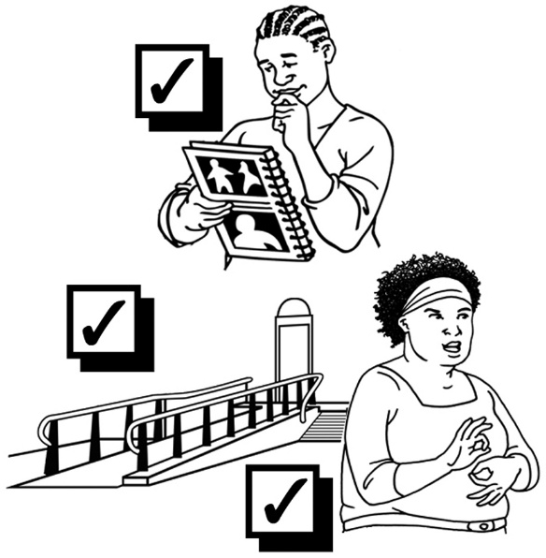
The Arts For All Network is for people who want to make the arts more accessible for:
deaf / Deaf people
disabled people.
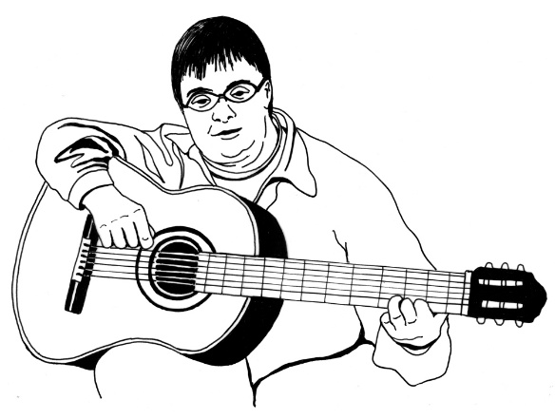

The arts includes things like:
music
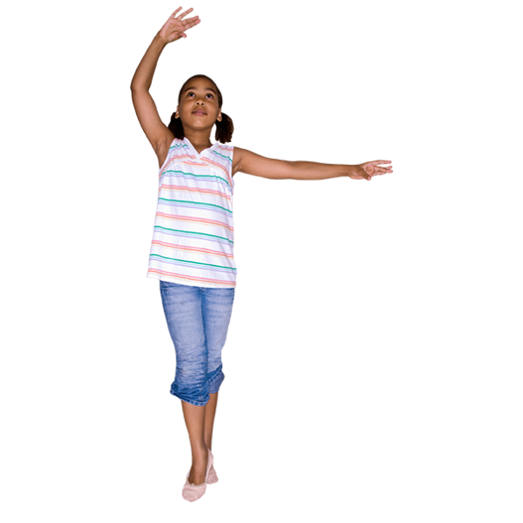
painting
dance
weaving.
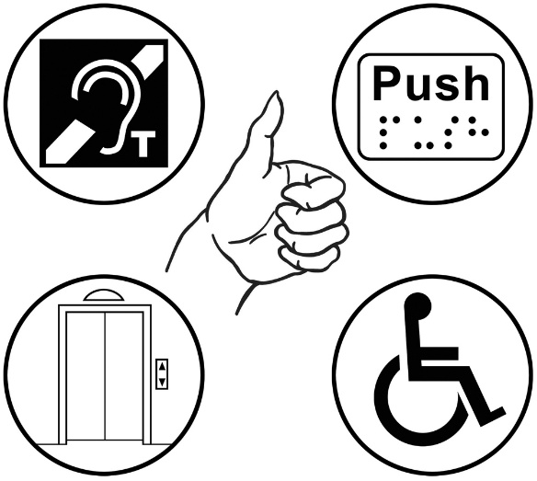
If something is accessible it means everyone can:
use it
take part.
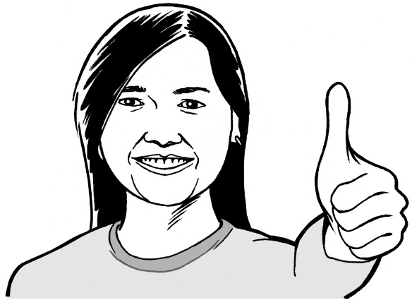

When you see we / us / our it means the Arts For All Network.

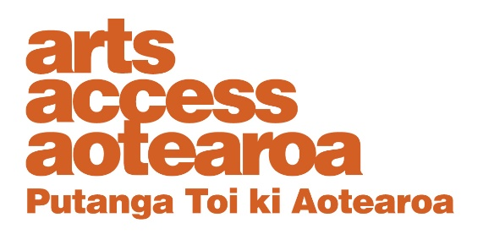
The Arts For All Network is part of Arts Access Aotearoa.

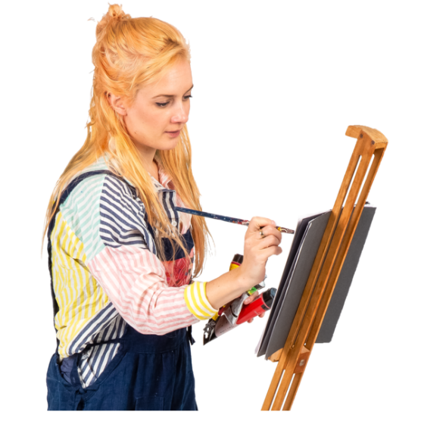
Arts Access Aotearoa is an organisation that supports people so they can be part of the arts including:
disabled people
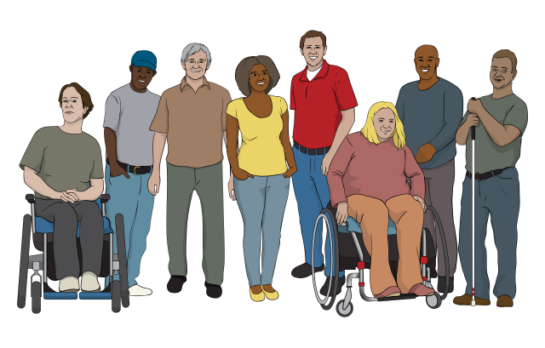
Deaf communities
mental health communities.

What is the Arts For All Network?

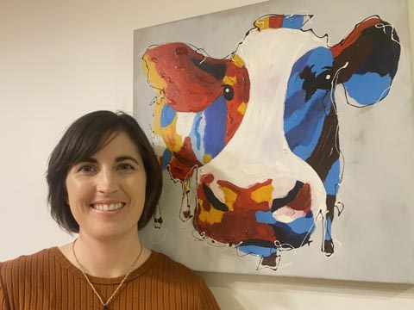
The Arts For All Network is led by Katie.

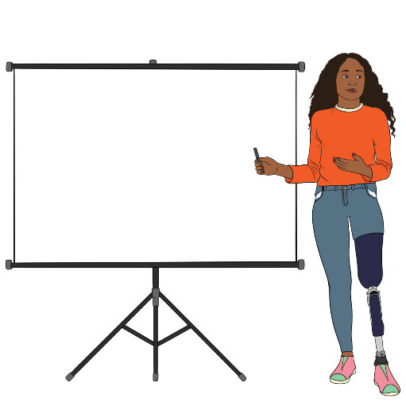
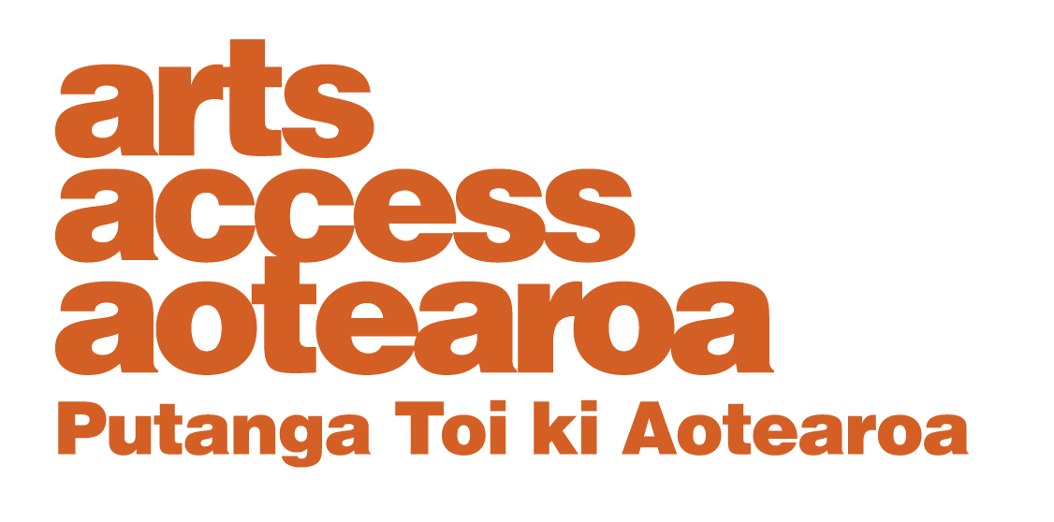
Katie is:
the Arts For All Activator – Whakahoehoe a Toi Ōritetanga
a disabled person.

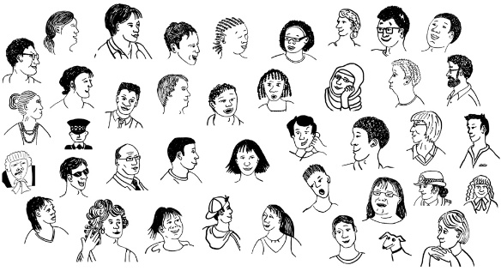
The Arts For All Network has about
1 thousand members around Aotearoa New Zealand.

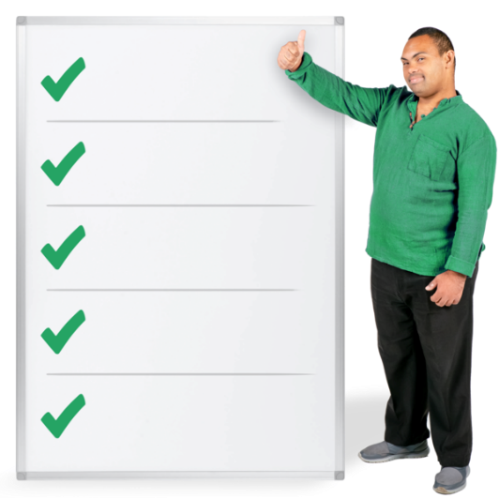
We:
give information to support organisations to make their accessibility better
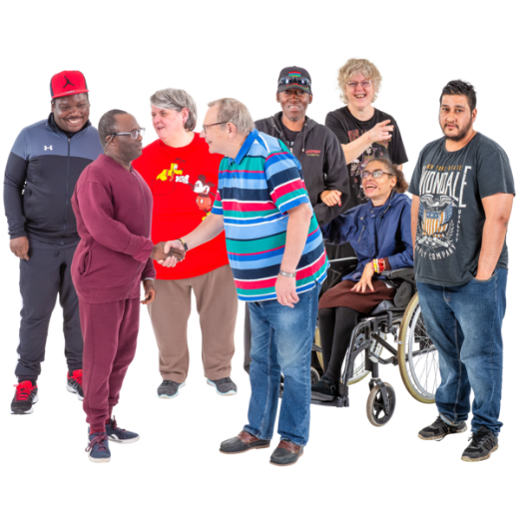
visit arts communities in Aotearoa New Zealand
connect Arts For All Network members to each other.

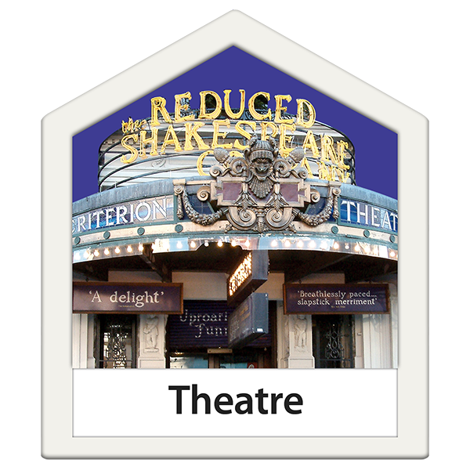
Some members belong to arts organisations like:
theatres
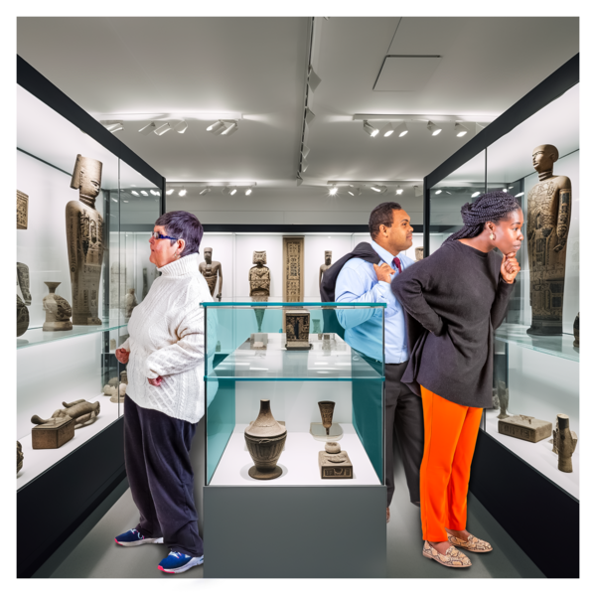
festivals
galleries which are where people can look at art
festivals.

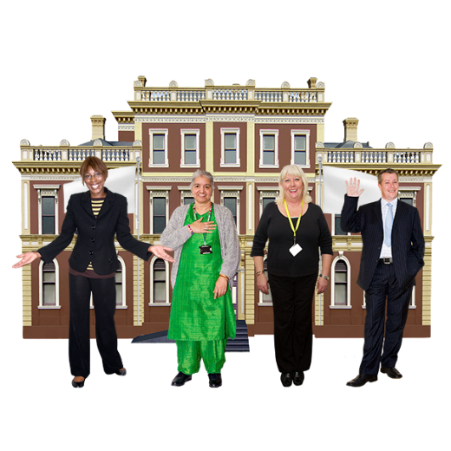
Some members work for places that do some work in the arts like:
local councils
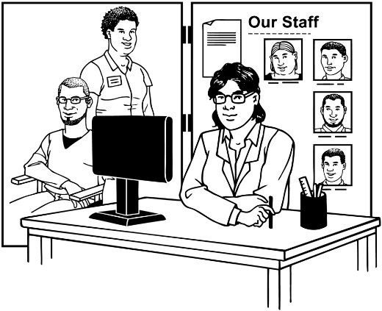
accessibility service providers
disabled persons organisations.
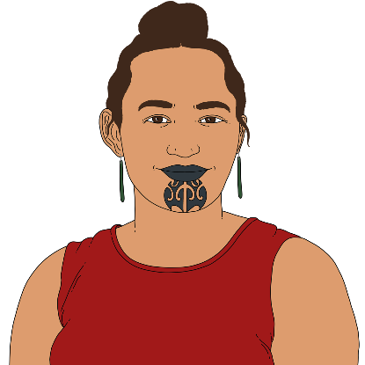
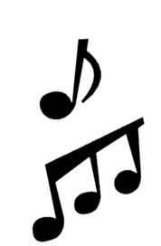

Some members are people who work on their own in the arts like artists.


The Arts For All Network brings Deaf and disabled people together with allies to:
connect
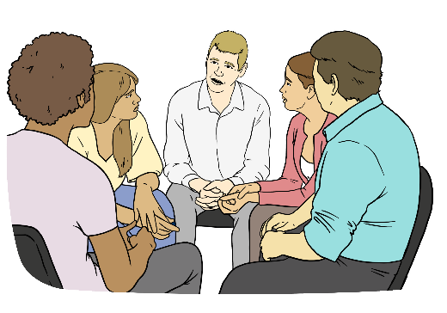
share
learn.


Here allies means non-disabled people who:
want to support Deaf and disabled people
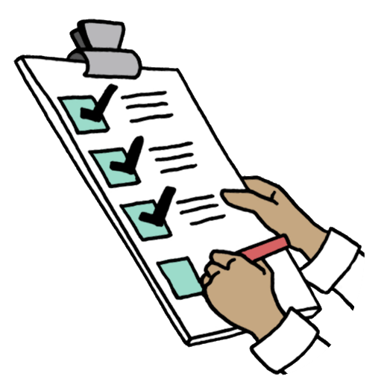
and
are working on making accessibility in the arts better.

How to join the Arts For All Network

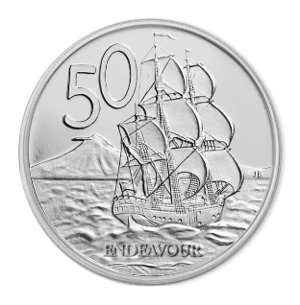
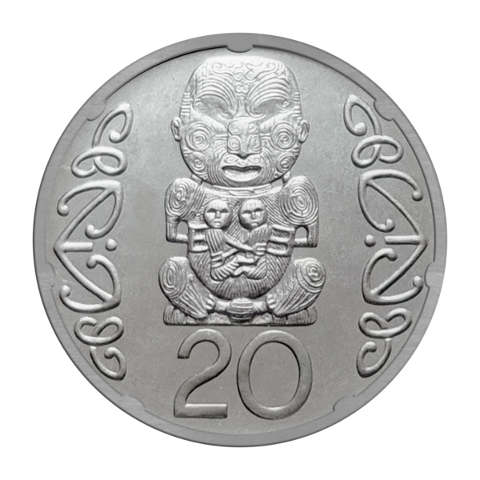
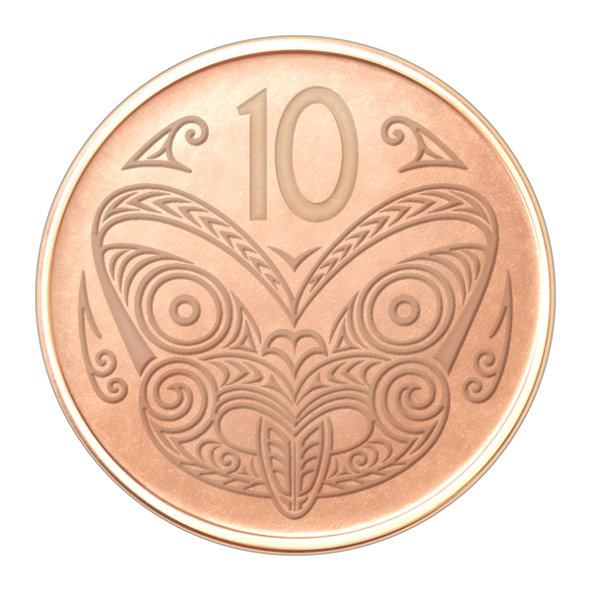

It does not cost any money to be part of the Arts For All Network.

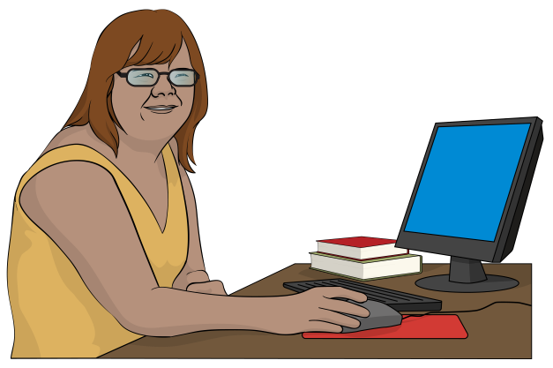
You can join using:
the form on our website
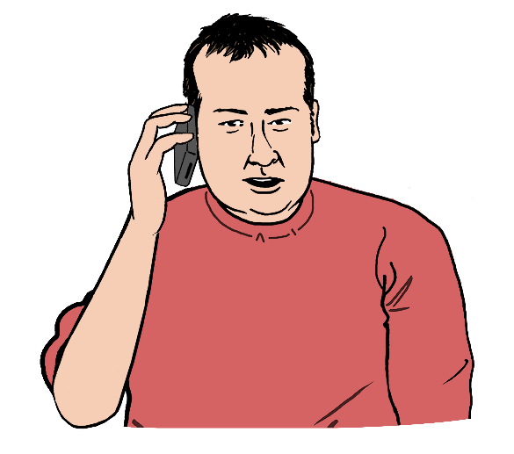
email
phone.

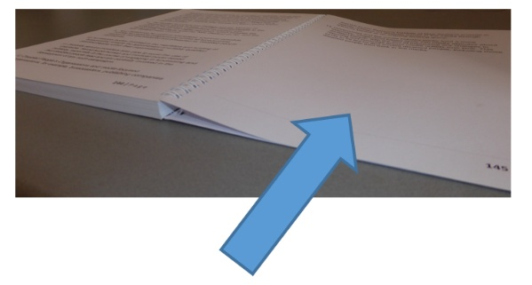
All the information on how to get in touch with us is on page 17.

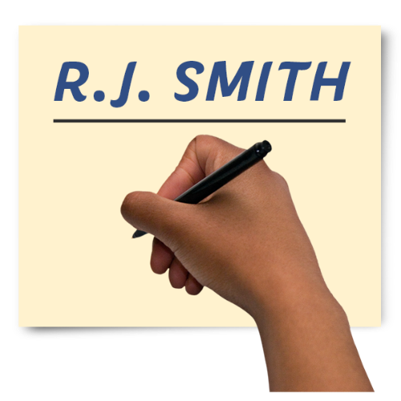
When you ask to join please tell us:
your name
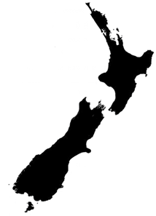
what part of Aotearoa New Zealand you live in
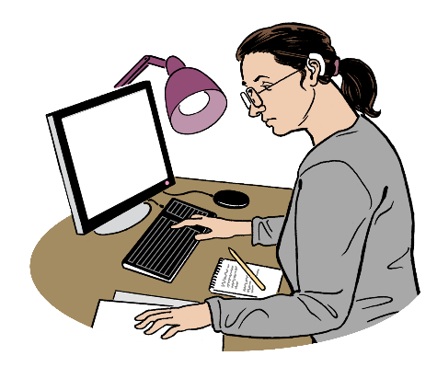
if you are part of an organisation tell us what it is
your job or what kind of art you do.

In-person hui / meetings

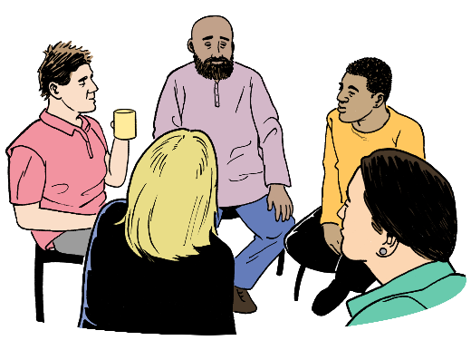
We visit different places around Aotearoa New Zealand to have
in-person hui / meetings.

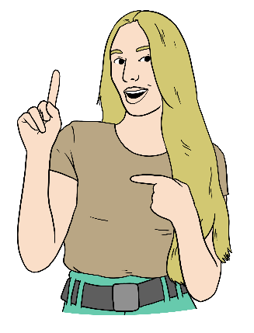
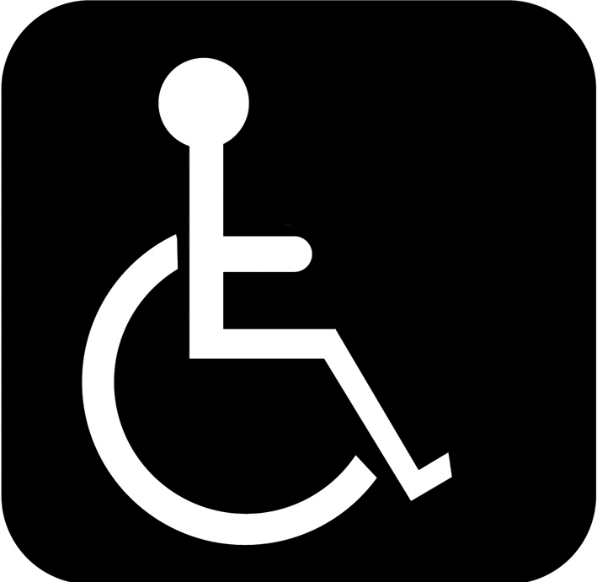

At the hui / meetings Arts For All Network members:
talk about the work they do for arts accessibility

ask questions
get to know other members.

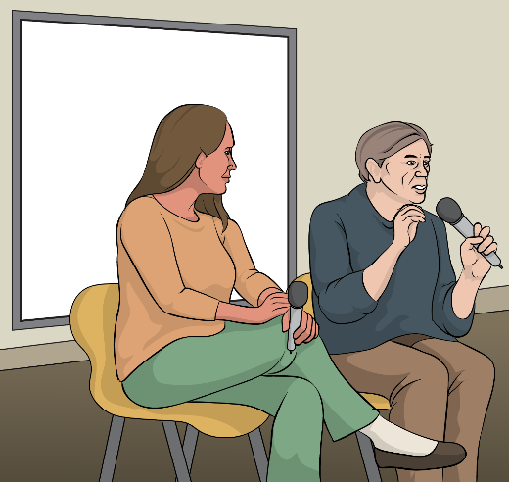
At the hui / meetings there might be:
someone giving a talk
a slideshow.

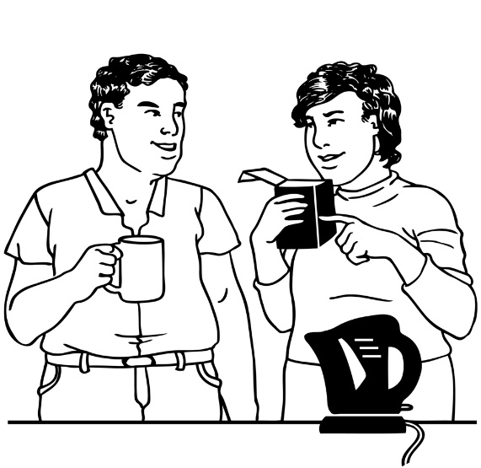
At the hui / meetings there is a break in the middle for:
snacks
drinks.


We invite members to in-person
hui / meetings by email.

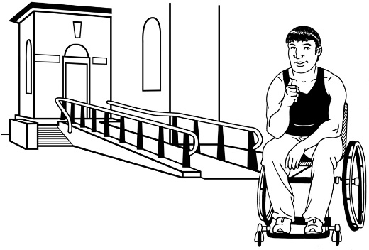
All in-person hui / meetings are in spaces that are wheelchair accessible.

Members are welcome to bring their:
support person
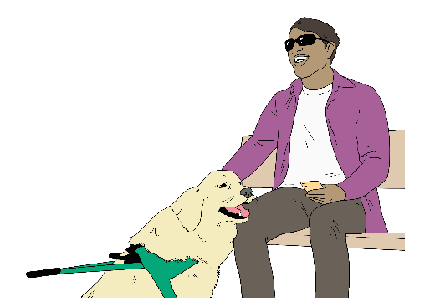
service dog.

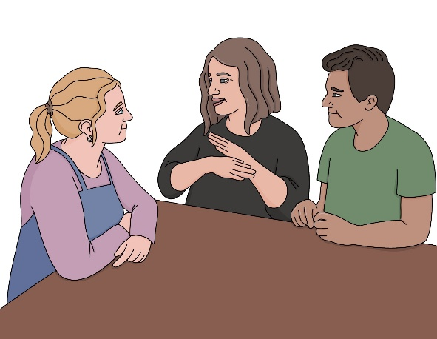
Let us know if you need a
New Zealand Sign Language / NZSL interpreter.

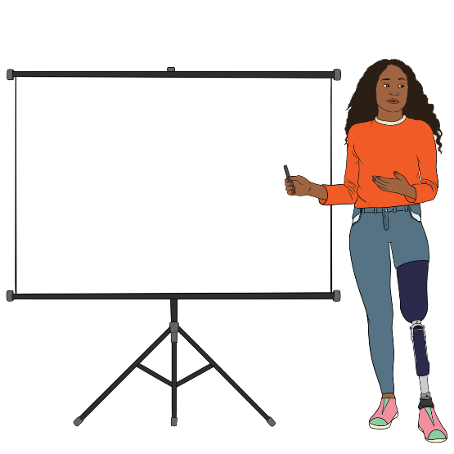
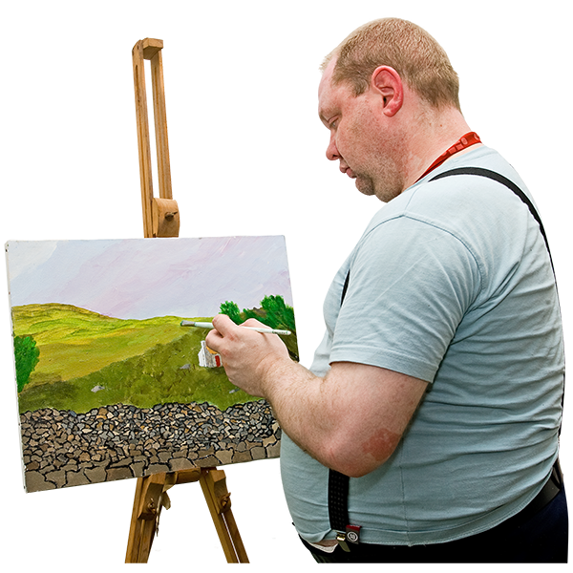
Slideshows will be described so blind and low vision people can follow what is on the screen like the:

images
words.

Online hui / meetings


You can join us for our online
hui / meetings if you live anywhere in Aotearoa New Zealand.

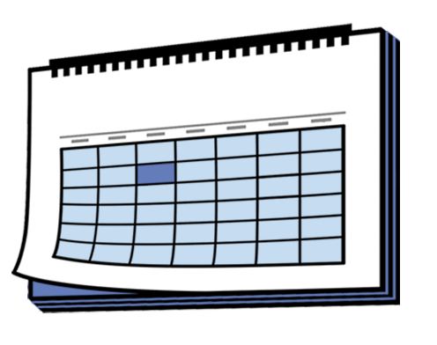
Our online hui / meetings happen at least once a month.

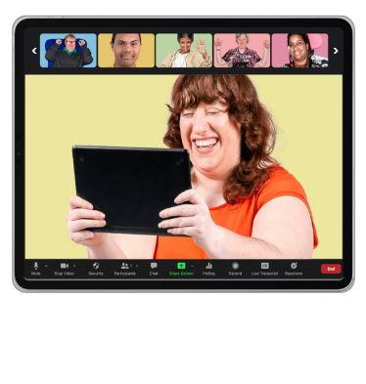
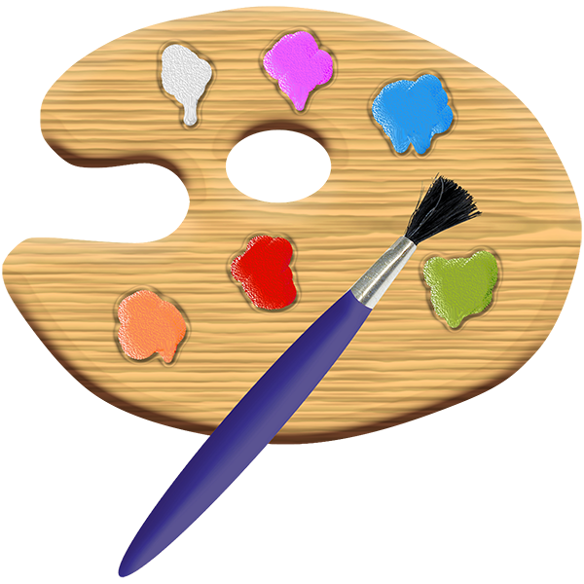
The online hui / meetings might have:

guests who talk to members about interesting things they are doing

members:
- sharing what they know
- learning from each other.

Let us know if you need a
New Zealand Sign Language / NZSL interpreter.


News
Information about the online
hui / meetings can be found:

at the start of the Arts For All Network newsletter
on our website:
www.artsaccess.org.nz

The Arts For All Network newsletter:
comes out every month
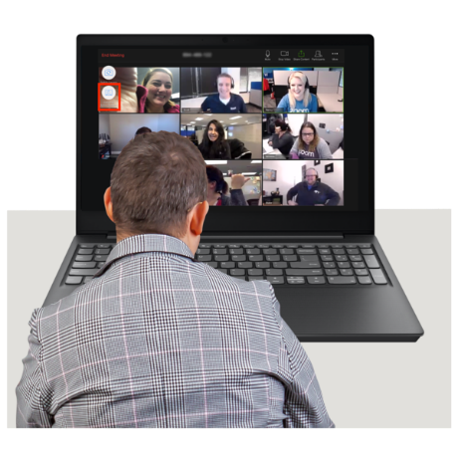
has information about
hui / meetings happening:

- online
- in-person.

The Arts For All Network newsletter also has:
notes about what happened at the last online hui / meeting
arts accessibility:
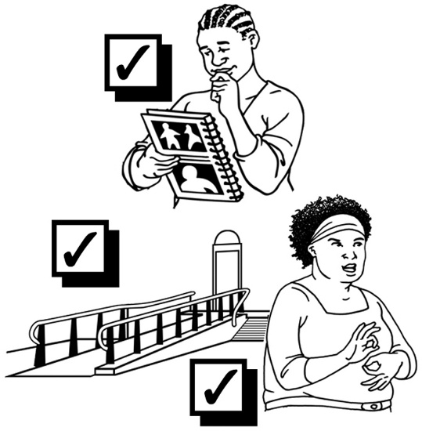
- tips which are easy things to do to make things more accessible
- information.

Talk to us 1 on 1

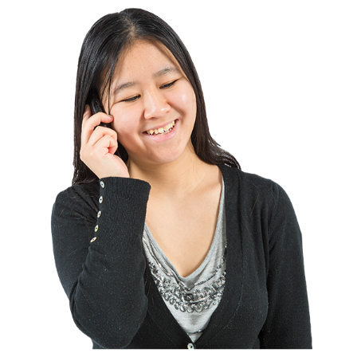
Network members can ask us questions about arts accessibility by:

phone
email
video call.

Information on how to contact us is on page 17.
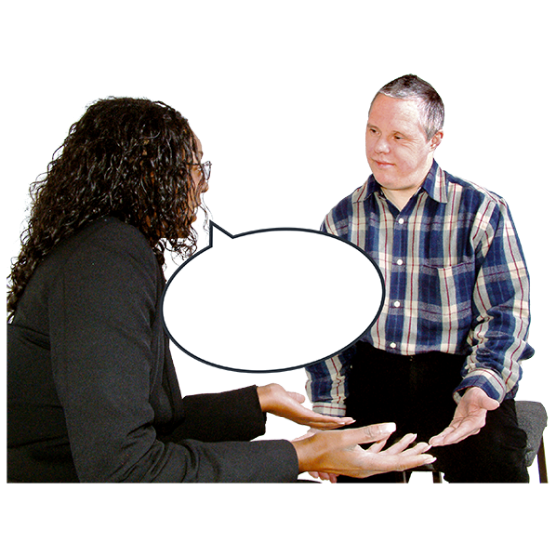

We can help you promote your accessible arts event.


Here promote means to
advertise / tell people about something happening.
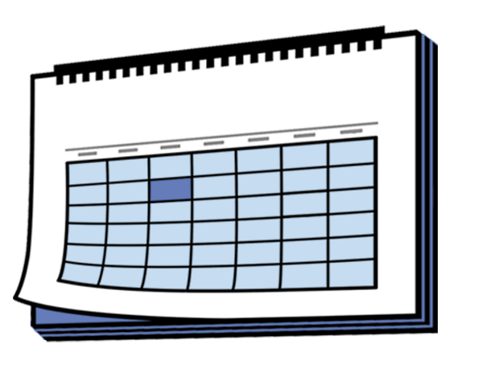
You can ask us to:
Events
share your event on the Arts Access Aotearoa events calendar
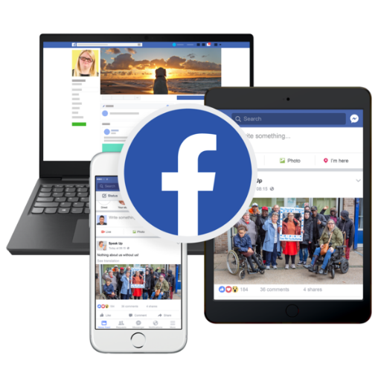
share the event on our social media
write a story about your art for our members to read.

How to get in touch with us

You can email the Arts For All Network at:

afa@artsaccess.org.nz

You can phone us on:

04 802 4349

It may cost you money to phone this number.


Our website is at:

www.artsaccess.org.nz

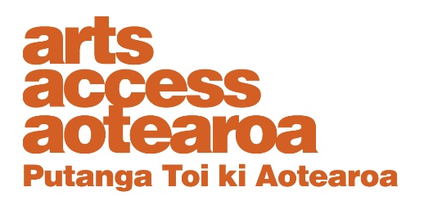
This information has been written by Arts Access Aotearoa.

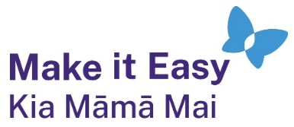
It has been translated into Easy Read by the Make it Easy Kia Māmā Mai service of People First New Zealand Ngā Tāngata Tuatahi.
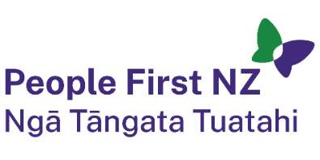
The ideas in this document are not the ideas of People First New Zealand Ngā Tāngata Tuatahi.

All images used in this Easy Read document are subject to copyright rules and cannot be used without permission.


Make it Easy uses images from:

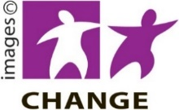
- Photosymbols

- Change Images

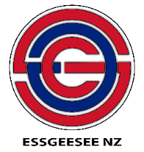
- Huriana Kopeke-Te Aho
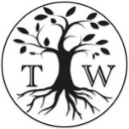
- SGC Image Works

- T Wood

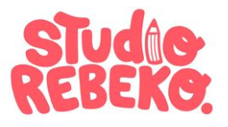
- Studio Rebeko

- Inga Kramer.

