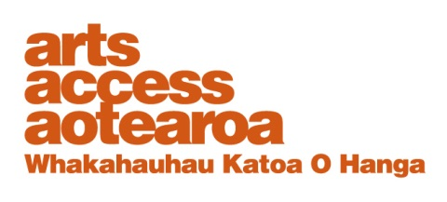
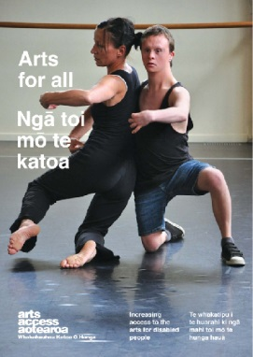
CASE STUDY: Arts For All

Suzanne Cowan: Dancer and choreographer
Arts For All is an Arts Access
Aotearoa/Creative
New Zealand partnership programme. The aim of this programme is to encourage arts
organisations, venues and producers to improve their
access to disabled audiences.
Download Arts For All, published in 2014 by Arts Access Aotearoa, at artsaccess.org.nz
or call 04 802 4349 for a hard copy.
For the full picture about arts and accessibility in New Zealand, you can download Arts For All | Ngā toi mo te katoa, published by Arts Access Aotearoa, 2014.

For the full picture about arts and accessibility in New Zealand, you can download Arts For All | Ngā toi mo te katoa, published by Arts Access Aotearoa, 2014.

For the full picture about arts and accessibility in New Zealand, you can download Arts For All | Ngā toi mo te katoa, published by Arts Access Aotearoa, 2014.

May 2010

1. My background: about me

A career as a dancer and choreographer might seem an unusual occupation for someone who uses a wheelchair but this has been my focus for the past ten years.

My passion for dance began at the tender age of five when I started ballet lessons. When I was 22 years old I was involved in a road accident in Canada and lost the use of my legs. Dance didn’t seem an option anymore and because I have always loved being active, I soon got involved in sailing and wheelchair tennis.

In 1998, I experienced Touch Compass Dance Company performing in
Auckland and my life took a whole new direction. After performing with
Touch Compass in 1999, in October I was offered a position as a full-time\ dancer with CandoCo Dance Company based in London. I spent the next three-and-a-half years touring internationally with them as a dancer and assistant teacher.

Since my return to New Zealand in 2004, I have been developing my own choreography and performing, with the support of Touch Compass. I also recently completed a Masters in Creative and Performing Arts at Auckland University. Right now, I am delighted to be in Dunedin, based at Otago University, as the Caroline Plummer Fellow for 2010.

Last year, I was involved in collating research for the Arts for All guide and it was a fascinating exercise getting a feel for the level of access to the arts in
New Zealand. What became really clear throughout the process was that “attitude” was one of the most defining factors. Even when a theatre or venue wasn’t physically that accessible the staff’s attitude and willingness to cater for someone with a disability made up for the lack of facilities. That has also been my personal experience.

2. What does access mean to you?

Access to me is all about attitude because underlying the physical barriers is an attitude or a belief system that created those physical barriers in the first place. We live in a world where only some people are catered for and others are not, and it’s only been in recent years that the idea of inclusiveness has emerged and gained some currency.

Access to me is being able to go through the front door just like everyone else rather than been taken around to a side entrance down a back alley.
Access is being able to choose my seat in a theatre and sit with my friends rather than been directed to the only accessible seat that happens to have bad sightlines.

Access is being able to enjoy the same service, the same privileges, with the same ease as everyone else. Access is about having my needs respected, as any courteous host knows how to do.

3. My journey: the barriers, challenges and the rewards

I’ve always been a keen supporter of the arts, even before my days as a performer. When I joined CandoCo Dance Company, the English dance company, I had the opportunity to tour the world and experience 24 different countries with their varying degrees of access and range of attitudes.
Naturally, as a company with disabled and non-disabled performers the theatres went to great lengths to make their facilities as accessible as possible.

In England, generally, the standard of access was very high, particularly the new theatres. In Russia, as you can imagine, the access was pretty diabolical but what they lacked in facilities, they made up with enthusiasm. I have memories of being carted up and down numerous flights of stairs, including the steps to the plane. It definitely wasn’t for the faint-hearted!

We spent a lot of time in Eastern Europe, and places like Serbia and Hungary were a real eye-opener. It wasn’t particularly easy for anyone to get around, let alone people with disabilities. It was at times like these that I realised just how lucky I was to come from a relatively wealthy country. The challenge for me during these years was continually adapting to a wide range of conditions and circumstances. As with any traveller there were often delays and difficulties, sometimes compounded by a lack of access. At these times I was always grateful to be travelling with a bunch of companions that helped to see the lighter side of some pretty frustrating situations.

When I look back at my time of international travel I can see that it takes willingness on both sides to find an accessible solution. I needed to be open to things being less than perfect and work with the conditions, and our hosts needed to listen carefully to our needs and requirements, making the best use of their resources.

The hard work and the hassle were always worth it when you saw the results.
Audiences were incredibly appreciative and it was rewarding to be able to offer a genuinely accessible performance on a number of different levels.
Not only could a disabled audience access the theatre but they were also able to identify with the performers, as people not so different to themselves.
Access, then, doesn’t only apply to the physical environment. It also applies to the artistic content. It’s important that disability is part of the fabric of artistic life, reflecting an integral part of human experience.

4. Three top tips to becoming more accessible

- Develop a policy for inclusiveness, a statement of intent.
- Create a practical priority list for making your venue/organisation more accessible – beginning with the easiest, least expensive solutions and progressing to the more costly ones.
- Train your staff in how to respond to the needs of people with disabilities.

5. Looking ahead: the impact that being accessible will have on New Zealand arts

Making New Zealand arts accessible to people from all walks of life is a mark of how progressive New Zealand really is. Kiwis have an international reputation for being innovative and at the helm of social change, and this needs to be reflected in our artistic life and our communities. Providing accessible venues and more opportunities for people and artists with\ disabilities will make our arts richer and more diverse for everyone. And it can only build new audiences for theatres, galleries and concert halls.

