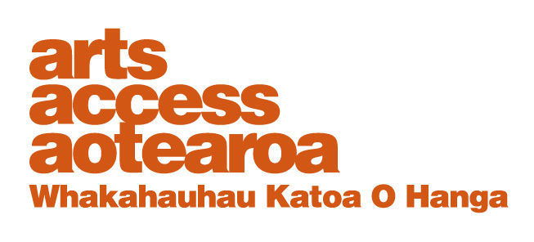
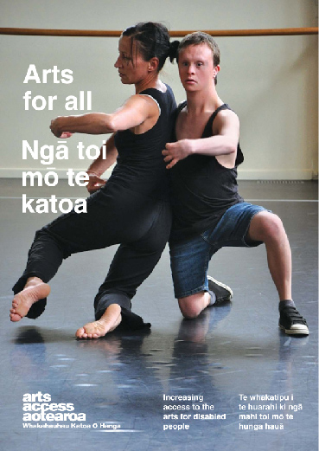
CASE STUDY: Arts For All

Signal at the Edge, Auckland
Arts For All is an Arts Access
Aotearoa/Creative
New Zealand partnership programme. The aim of this programme is to encourage arts
organisations, venues and producers to improve their
access to disabled audiences.
Download Arts For All, published in 2014 by Arts Access Aotearoa, at artsaccess.org.nz
or call 04 802 4349 for a hard copy.
For the full picture about arts and accessibility in New Zealand, you can download Arts For All | Ngā toi mo te katoa, published by Arts Access Aotearoa, 2014.

For the full picture about arts and accessibility in New Zealand, you can download Arts For All | Ngā toi mo te katoa, published by Arts Access Aotearoa, 2014.

For the full picture about arts and accessibility in New Zealand, you can download Arts For All | Ngā toi mo te katoa, published by Arts Access Aotearoa, 2014.

September 2012
Stephanie Clarke, Assistant Producer at THE EDGE in Auckland, talks to Arts Access Aotearoa about SIGNAL, a programme offering sign language interpreted performances and audio described performances of productions at its four venues: the Auckland Town Hall, the Aotea Centre (including the Herald Theatre and ASB Theatre), the Aotea Square and the Civic.

1. Background: about the programme
There were two reasons why this programme started. The first, and most important one, was a recognition that there were people in the wider Auckland community who weren’t able to be audience members here because we simply weren’t providing the facilities for them to be able to do so. Obviously, that’s far from an ideal situation.

Secondly, Bronwyn Bent, Producer of Foundation Programmes at THE EDGE, was the driving force in getting the programme up and running. Bronwyn had worked on audio described and sign language interpreted shows in the UK, and knew what great experiences they provided for audiences, cast and crew. She also knew we would be able to do at least a little of that here in Auckland too.

In 2009, Bronwyn started meeting with a few key groups, including the Royal New Zealand Foundation for the Blind and Deaf Aotearoa. They gave valuable advice, especially in regards to how we market shows to audience members who may never have been to a show.

From there, Bronwyn had to find some money to make it happen. This meant finding little pockets in THE EDGE’s existing budgets, which could be used to employ a programme co-ordinator who could make it all happen.

2. The process: setting up the programme

After the initial consultation with the various communities, THE EDGE employed me in February 2010 to set up and co-ordinate the programme: in other words, make it all happen.

I had previous experience running a similar programme at the Bristol Old Vic, a producing theatre in England. That meant I knew what needed to be done in order for it to run successfully in Auckland.

The key elements for a successful programme include:

- getting companies interested and on board
- finding the right audio description equipment
- finding a pool of professional sign language interpreters
- employing and training audio describers
- finding someone with enough experience in visual literacy to train new and inexperienced audio describers
- training for front-of-house staff: ushers and ticketing
- marketing the programme and shows to the relevant community groups in accessible formats.

3. What were some of the key challenges in setting up the programme?

- Creating awareness: A lot of people, both at THE EDGE and in the community, had never heard about sign language interpreted performances and audio description. It was essential that everyone at THE EDGE and the theatre companies using our venues (for example, Auckland Theatre Company and Silo) were given a lot of information so they felt confident and excited about what to expect, and the potential benefits.
- Getting companies on board: Providing the service was in its infancy here and most companies had a lot of concerns that needed addressing. Among the main concerns were the cost and resources required; plus the impact the programme could have on their existing patrons. Would it be distracting for them?
- Getting the equipment: It’s important to have good-quality transmitters and receivers for the audio description so the experience for patrons is really positive. This was achieved through feedback, and trial and error. I am looking for funding for us to buy our own equipment, which would significantly reduce the cost of each performance.

4. Any ongoing issues?
Money is always an issue. THE EDGE allocates some funding every year but it’s a small amount and limits the number of sign language interpreted and audio described performances we can support. At the moment, there’s no cost to the other companies offering these performances and it would be great if they were able to contribute.
To give you an idea … It costs around $3000 to do an audio described performance. If we had our own equipment, it would cost around $2000. The cost of sign interpreted performances varies, depending on the length of the shows.

The other ongoing issue is the lack of audiences. The first SIGNAL performance was in June 2010 and the vast majority of potential audiences are still unaware of what audio description is; or they’ve never been to the theatre before because sign language interpretation was not on offer.

5. How do you evaluate the programme? What do results show to date?
We run feedback sessions with EDGE staff and SIGNAL patrons, and then make tweaks to the programme. So, for example, when we first offered audio description we got feedback that the sound quality wasn’t very good, and so we found a new provider and the problem was solved. Another example: the Deaf community told us that a lot of Deaf people hadn’t been to the Aotea Centre and, in fact, some hadn’t been to the theatre before. They didn’t know where to go and how to get tickets. We produced a signed video and posted it on our website to make people feel more comfortable about coming to the theatre.

Our evaluations show that people who have been to a performance are coming back. We’re getting a good group of regulars now but we need to go out further and find a new audience.

At the moment, we’re evaluating how we’re reaching people and we’re in discussion with the communities about the best communication channels. As well as signed and audio videos, we’ve started using specific logos to identify the service we’re offering.

During one feedback session, the Deaf community asked for ballet and the vision impaired group asked about opera. I’m pleased to say we have included both in this year’s programme. First up, we provided a sign language interpreted talk during the interval of a schools matinee performance of the Royal New Zealand Ballet’s Cinderella. Now, we’re offering a touch tour and audio described performance of NBR New Zealand Opera’s The Bartered Bride in Auckland and Wellington over September and October this year.

6. Do you have five tips for other venues and arts organisations wanting to setting up a similar programme?

- Take time to train audio describers. You want to offer a good product so people have an enjoyable experience and keep coming back.
- Provide training for front-of-house and ticketing. It empowers and gives them the confidence to enjoy offering the service.
- Contact the key communities who will be your audience. Face-to-face meetings work best.
- Be prepared to tweak things. You’re not necessarily going to get everything right first time. Listen and respond to feedback. It’s a learning process for everyone.
- Use the international logos below: it would be good to develop a national standard that people can start to recognise easily.
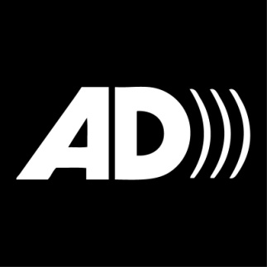

8. Future plans for SIGNAL?
I am busy applying for funding to buy the audio description equipment, which costs about $20,000. This would significantly save on our costs per performance and enable us to do more.

We are also hoping that an international theatre sign language interpreter will run a workshop in Auckland in early 2013. The National Foundation for the Deaf Trust is very supportive and we are waiting to see if we receive other funding to make it happen. It will be open to professional signers nationally.

THE EDGE would like to offer this opportunity to other individuals and organisations keen to provide this service in other places in New Zealand. The course would include people from the Deaf community, who would become ongoing mentors.

