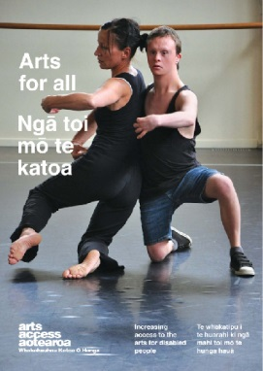
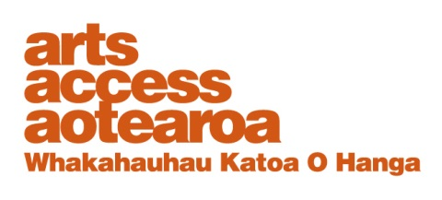
CASE STUDY: Arts For All

Taki Rua Productions: Developing an accessibility policy
Arts For All is an Arts Access
Aotearoa/Creative
New Zealand partnership programme. The aim of this programme is to encourage arts
organisations, venues and producers to improve their
access to disabled audiences.
Download Arts For All, published in 2014 by Arts Access Aotearoa, at artsaccess.org.nz
or call 04 802 4349 for a hard copy.
For the full picture about arts and accessibility in New Zealand, you can download Arts For All | Ngā toi mo te katoa, published by Arts Access Aotearoa, 2014.

For the full picture about arts and accessibility in New Zealand, you can download Arts For All | Ngā toi mo te katoa, published by Arts Access Aotearoa, 2014.

For the full picture about arts and accessibility in New Zealand, you can download Arts For All | Ngā toi mo te katoa, published by Arts Access Aotearoa, 2014.

March 2012
Esther Green, Operations Manager, Taki Rua Productions, talks to Arts Access Aotearoa about what was involved in developing the organisation’s accessibility policy.

1. Background: about us
Taki Rua Productions is Aotearoa New Zealand’s leading national Māori theatre company. We produce Māori theatre works that tour to diverse audiences throughout Aotearoa New Zealand and the world.
My role is Operations Manager and together with the Tumuaki/Artistic Director, James Ashcroft, I manage the operational, organisational and creative areas of the company. We’re a small organisation and only James and I are employed fulltime. Production personnel are contracted to work on our annual programme when required.
We produce between two to four works every year. We have a special focus on getting works to youth audiences, especially through our Te Reo Māori Season. Our other areas of focus are developing emerging artists, creating innovative new works, and ensuring that New Zealand works and artists are heard, seen and celebrated, both nationally and internationally.

We put a lot of effort into reaching audiences who are isolated, either geographically or financially. Developing an accessibility policy is about extending Taki Rua’s reach to disabled people.

I started working at Taki Rua in 2009, after completing a performing arts degree (acting) at Toi Whakaari and spending two years making my own work and performing. I am passionate about using my organisational, leadership and business skills to develop creative environments that encourage the best in our artists and their work.

2. What motivated Taki Rua to develop an accessibility policy and where did you start?

What motivated me was attending the Arts For All Wellington Network forums and discussion groups over 2010 and 2011. I was inspired by people like Stew Sexton (disability awareness consultant, AbilityDis), people from the blind and Deaf communities, and by what Arts Access Aotearoa is doing to raise awareness. I began to see the value to an arts organisation in being accessible, and the importance of having an accessibility policy to guide the organisation.

I started having conversations with other people at Taki Rua – just getting them to think about access and why we should have a policy. After that, I went to a few more workshops and identified potential partnerships with companies that have similar activities – theatre, performing arts, touring and festivals. I also talked to network members about what they were doing in terms of accessibility policies and how they were doing it.
3. Outline the key steps you took from the policy’s beginning through to its ratification and implementation.

- I got staff and board buy-in to start the process by having conversations and meetings with our Tumuaki/Artistic Director, who then introduced the idea to our trustees.
- I had a good read of Arts Access Aotearoa’s resources, including the Arts For All publication and the online templates and information sheets.
- I talked to other companies about how they developed their accessibility policies and the sorts of issues they faced.
- In all of this, I kept going back to Taki Rua’s vision and mission. These became the springboard for the policy, and how we could extend our programme to reach a more diverse audience.
- Using some of the Arts For All resources, I wrote a first draft that was unique to Taki Rua and its kaupapa.
- After I’d written a second draft, I got feedback from our Tumuaki and a couple of trustees. Once I’d taken in their feedback and created a final draft, James took it to the board for ratification.
- Once you have the policy, you need to make sure it’s more than a piece of paper. I started looking at opportunities to implement the policy: for example, we did an audio described performance of Awhi Tapu at Downstage Theatre last year. The other thing we do is send out copies of the play scripts to teachers before we visit their schools during Te Reo Māori Season.

4. What were the main challenges and how did you overcome them?
- Getting staff and board buy-in:
I was pretty persistent. Armed with the research I did, I talked a lot about why and how we should be developing an accessibility policy.
- Time and resources to do the research, create a draft policy and plan the implementation:
Accessibility isn’t written into most people’s job description, including mine, and so I thought about how I could do it strategically and efficiently, building on what Taki Rua already offers. It’s about commitment really. You need to ask yourself how important you think it is and whether you care enough to go through with it. In my case, the answer was “yes”.
- The cost of implementation: Cost is always a factor for arts organisations working within tight budgets. Ideally, you should allow for your accessible initiatives (e.g. audio description and signed performances) in your annual budget. This usually means applying for additional funding through philanthropic trusts – where getting the funding definitely isn’t a given.
- Having personnel on the ground able to implement your accessibility policy and initiatives: We’re gradually building up a network of people who have the skills required to create accessible productions.
5. How and when did you involve Taki Rua’s board?
After I’d written a second draft, I sent the document to a couple of board members for feedback. They asked me three important questions. How much work will it involve? What will it cost? Can we deliver on it?
Then I wrote a third draft and our Tumuaki, James, took it to the board for sign-off. Taki Rua is a small organisation and I have to be realistic about what we can achieve. I don’t put too much pressure on myself: instead, I think about strategic opportunities where we can do something that will make a difference.
Besides, accessibility is not just about doing initiatives. It’s also about raising awareness – and that can be a simple conversation with someone.

6. What are your four top tips for organisations wishing to develop and implement an accessibility policy?
- Just do it. Have a go!
- Start with what you’ve already got: your organisation’s vision and values.
- Talk to people and use Arts Access Aotearoa’s resources.
- Go to a performance (e.g. an audio described performance) and see how much the patrons enjoy it.

7. Looking ahead: how do you ensure the policy remains relevant to Taki Rua and its audiences?

Your accessibility policy has got to be a living, flexible document that can evolve as your activities and budgets change. You should review your policy every time you plan your year’s programme, looking at every activity and thinking about how you could reach a new audience.

Factor any accessible activity into your budget, if possible, and consider ways to resource it. And keep looking for new partners who could support your accessible initiatives – whether it’s financial, in-kind, or with skills and knowledge.

